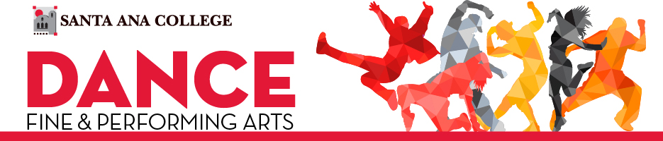

**SAC FALL 2024 SCHEDULE**

**Click on the QR code for access to the F24 schedule**

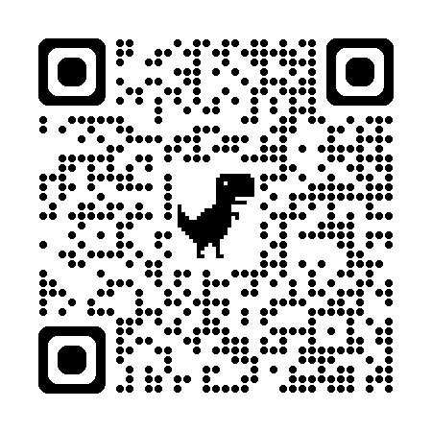

**Monday/Wednesday - All Dance Classes in G-108**

|  |  |  |  |
| --- | --- | --- | --- |
|  |  |  |  |
| **10:05a – 11:30a** | DNCE 201A | Ballet I | #27101 |
| Full 16 weeks | DNCE 201B | Ballet II | #27108 |
| In-class/Hybrid | DNCE 213 | Ballet III | #46738 |
|  | DNCE 214 | Ballet IV | #46739 |
|  |  |  |  |
| **1:25p – 2:50p** | DNCE 120A | Intro to Hip-Hop | #28458 |
| 10/14 - 12/8; 2nd 8-week session | DNCE 120B | Inter. Hip-Hop | #27102 |
| In-Class/Hybrid |  |  |  |
|  |  |  |  |
| **4:00p – 5:25p (Monday ONLY)** | DNCE 110 | Beg. Mexican Folk Dance | #46735 |
| Full 16 weeks | DNCE 111 | Inter. Mexican Folk Dance | #46736 |
| In-Class/Hybrid |  |  |  |
|  |  |  |  |
| **6:00p – 7:30p** | DNCE 114 | Conditioning for Dance | #47386 |
| 10/14 - 12/8; 2nd 8-week session |  |  |  |
| In-Class/Hybrid |  |  |  |
|  |  |  |  |
| **7:30p – 9:40p** | DNCE 122A | Commercial Dance | #46737 |
| 10/14 - 12/8; 2nd 8-week session |  |  |  |
| In-Class/Hybrid |  |  |  |



**SAC FALL 2024 SCHEDULE**

**Tuesday/Thursday - All Dance Classes in G-108**

|  |  |  |  |
| --- | --- | --- | --- |
|  |  |  |  |
| **8:30a – 9:50a** | DNCE 109A | Pilates I | #47364 |
| 10/14 - 12/8; 2nd 8-week session | DNCE 109B | Pilates II | #47372 |
| In-Class/Hybrid |  |  |  |
|  |  |  |  |
| **10:05a – 12:10p** | DNCE 206A | Modern Dance I | #27111 |
| Full 16 weeks | DNCE 206B | Modern Dance II | #27113 |
| In-Class | DNCE 209 | Modern Dance III | #27114 |
|  | DNCE 210 | Modern Dance IV | #36937 |
|  |  |  |  |
| **12:20p – 1:45p** | DNCE 202A | Choreography | #33136 |
| Full 16 weeks | DNCE 202B | Choreography for Dance | #33137 |
| In-Class/Hybrid |  |  |  |
|  |  |  |  |
| **4:10p – 6:15p** | DNCE 219A | Jazz Dance I | #27116 |
| Full 16 weeks | DNCE 219B | Jazz Dance II | #27117 |
| In-Class | DNCE 220 | Jazz Dance III | #27118 |
|  | DNCE 221 | Jazz Dance IV | #36939 |
|  |  |  |  |
| **6:30p – 8:35p** | DNCE 250A | Hip-Hop Dance I | #28461 |
| Full 16 weeks | DNCE 250B | Hip-Hop Dance II | #28462 |
| In-Class |  |  |  |
|  |  |  |  |



**Lecture/On-line Classes**

|  |  |  |  |
| --- | --- | --- | --- |
|  |  |  |  |
| **DNCE 100** | **Dance History; In-Class** | **10:05a-11:25 M/W** | **#26984** |
|  | **Dance History; On-line** | **Full 16 weeks** | **#26990** |
|  | **Dance History; On-line** | **8/19 - 10/13**  **1st 8-week session** | **#47327** |
|  | **Dance History; On-line** | **10/14 - 11/10**  **4-week session** | **#46787** |
|  |  |  |  |
| **DNCE 101** | **Dance as Communication; On-line** | **8/19 - 10/13**  **1st 8-week session** | **#27001** |
|  |  |  |  |
| **DNCE 105** | **World Dance & Cultures; On-line** | **Full 16 weeks** | **#27010** |



**SAC FALL 2024 SCHEDULE**

**Dance Concert Production Classes**

|  |  |  |
| --- | --- | --- |
|  |  |  |
| DNCE 009A | Dance Lab I | #26965 |
| DNCE 009B | Dance Lab II | #26966 |
| DNCE 009C | Dance Lab III | #26928 |
| DNCE 009D | Dance Lab IV | #26976 |
|  |  |  |
| DNCE 107A | Dance Concert Performance I | #46740 |
| DNCE 107B | Dance Concert Performance II | #46743 |
| DNCE 107C | Dance Concert Performance III | #46750 |
| DNCE 107D | Dance Concert Performance IV | #47353 |
|  |  |  |
| DNCE 240A | Repertory I | #27119 |
| DNCE 240B | Repertory II | #27120 |
| DNCE 240C | Repertory III | #27121 |
| DNCE 240D | Repertory IV | #27122 |

**Tentative Weekly Rehearsal Schedule**

|  |  |  |  |  |  |  |  |  |  |  |
| --- | --- | --- | --- | --- | --- | --- | --- | --- | --- | --- |
| **M** | **M** | **T** | **T** | **W** | **W** | **TH** | **TH** | **F** | **F** | **F** |
| **11:40 - 1:15p** | **1:30 – 3:30p** | **2:00 – 4:00p** | **8:40 – 10:00p** | **11:40 - 1:15p** | **1:30 – 3:30p** | **2:00 – 4:00p** | **8:40 – 10:00p** | **10:00 – 12:00p** | **12:00 –2:00p** | **2:00 – 4:00p** |

**Tech/Concert Rehearsal Schedule**

* **Saturday, November 9** **8a – 6p Costume/Space**
* **Saturday, November 16** **8a – 6p Costume/Space**
* **Monday, November 18 – Wednesday, November 20** **5p – 10p** **Final Tech**
* **Thursday, November 21 – Saturday, November 23** **5p – 10p** **Concert**