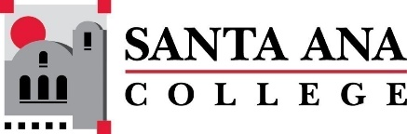 |  | SAC Program Review Committee Minutes  May 6, 2024  1:00 p.m. to 2:30 p.m.  Zoom: https://rsccd-edu.zoom.us/j/87584225311

Present: Professor Matthew Beyersdorf, Dr. Sara Butler, Lorena Chavez, Dean Saeid Eidgahy, Professor Catherine Emley, Dean Walter Jones, Professor Quynh Mayer, Professor Suanne Oh, Professor Kim Smith, Professor Katharine Walczak, and Professor Merari Weber.

Absent: Dr. Sara Butler, Dr. Brenda Estrada, and Professor Jaki King

1. Welcome

2. Capstone Review presentation by Auto/Diesel/Welding (SAC)

- Auto/Diesel/Welding by David Roper and Gregory Gonzales.

3. Capstone Review presentation by the Assessment Center (SAC)

- The Assessment Center presentation by Luz Fernandez Marquez.

4. Capstone Review presentation by Chemistry

- Chemistry presentation by Professor Jennifer McAdam.

5. Approval of April 29, 2024, minutes

- The minutes of April 29, 2024, were approved.

6. Review of Completed Capstone Program Review Rubrics for ESL (SCE), English (SAC), Nursing (SAC), the Speech-Language Pathology Assistant Program (SAC), Legal Studies (SAC), Math (SAC), Fire Technology (SAC), Philosophy (SAC), Global Business and Entrepreneurship (SAC), Career Center (SAC), and Communication Studies (SAC).

- This was tabled for a future meeting.

7. Next meeting: Monday, May 20, 2024, from 1:00 p.m. to 2:30 p.m.

