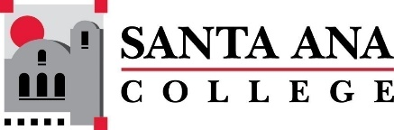 |  | SAC Program Review Committee Agenda  March 11, 2024  1:00 p.m. to 2:30 p.m.  Zoom: https://rsccd-edu.zoom.us/j/87584225311

1. Welcome

2. Capstone Review roundtable discussion with ESL (SCE) and English (SAC)

3. Capstone Review roundtable discussion with Nursing (SAC) and the Speech-Language Pathology Assistant Program (SAC)

4. Capstone Review presentation by Legal Studies (SAC)

5. Approval of February 26, 2024, minutes

6. Discussion of Capstone Program Review Rubrics

