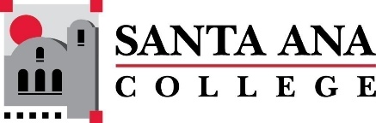 |  | SAC Program Review Committee Agenda  February 26, 2024  1:00p.m. – 2:00 p.m.  Zoom: https://rsccd-edu.zoom.us/j/88157127065
1. Welcome

2. Approval of November 27, 2024, minutes

3. Goodbyes and thank you

4. Dr. Lamb

5. Report on FLEX week workshop

6. Nuventive

7. List of programs with Capstone Reviews due in November of 2023:
- English as a Second Language (SCE) (submitted)
- Global Business and Entrepreneurship
- Legal Studies (submitted)
- Communication Studies (submitted)
- Philosophy
- English (submitted)
- Auto/Diesel/Welding (three programs)
- Fire Technology
- Child Development and Education Studies
- SLPA (submitted)
- EMLS (submitted)
- Chemistry (submitted)
- Mathematics (submitted)
- Nursing (submitted)
- Disabled Student Programs & Services (Student Services) (submitted)
- Assessment (Student Services) (submitted)
- Career Center (Student Services) (submitted)

8. Action Items:
- Workgroup to address question change
- What types of presentations?
  - roundtable and/or individual
- Future meeting dates March 11, March 25, April 15, April 29, May 6, and May 20
  - Holidays this semester include April 1, April 8, and May 27
- Presentation rubrics

