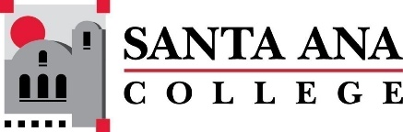 |  | SAC Program Review Committee Agenda  April 15, 2024  1:00 p.m. to 2:30 p.m.  Zoom: https://rsccd-edu.zoom.us/j/87584225311

1. Welcome

2. Capstone Review presentation by Math (SAC)

3. Capstone Review presentation by Fire Technology (SAC)

4. Capstone Review presentation by Philosophy (SAC)

5. Approval of March 25, 2024, minutes

6. Review of Completed Capstone Program Review Rubrics for ESL (SCE), English (SAC), Nursing (SAC), the Speech-Language Pathology Assistant Program (SAC), and Legal Studies (SAC)

