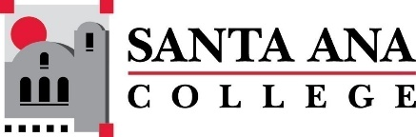 |  | SAC Program Review Committee Agenda  March 25, 2024  1:00 p.m. to 2:30 p.m.  Zoom: https://rsccd-edu.zoom.us/j/87584225311

1. Welcome

2. Approval of February 26, 2024, minutes

3. Approval of March 11, 2024, minutes

4. Capstone Review presentation by Legal Studies (SAC)

5. Review of Completed Capstone Program Review Rubrics for ESL (SCE), English (SAC), Nursing (SAC), and the Speech-Language Pathology Assistant Program (SAC)

