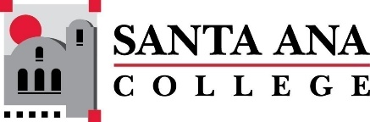 |  | SAC Program Review Committee Agenda  April 29, 2024  1:00 p.m. to 2:30 p.m.  Zoom: https://rsccd-edu.zoom.us/j/87584225311

1. Welcome

2. Capstone Review presentation by Child Development and Education Studies (SAC)

3. Capstone Review presentation by Global Business and Entrepreneurship (SAC)

4. Capstone Review presentation by Career Center (SAC)

5. Capstone Review presentation by Communication Studies (SAC)

6. Approval of April 15, 2024, minutes

7. Review of Completed Capstone Program Review Rubrics for ESL (SCE), English (SAC), Nursing (SAC), the Speech-Language Pathology Assistant Program (SAC), Legal Studies (SAC), Math (SAC), Fire Technology (SAC), and Philosophy (SAC).

