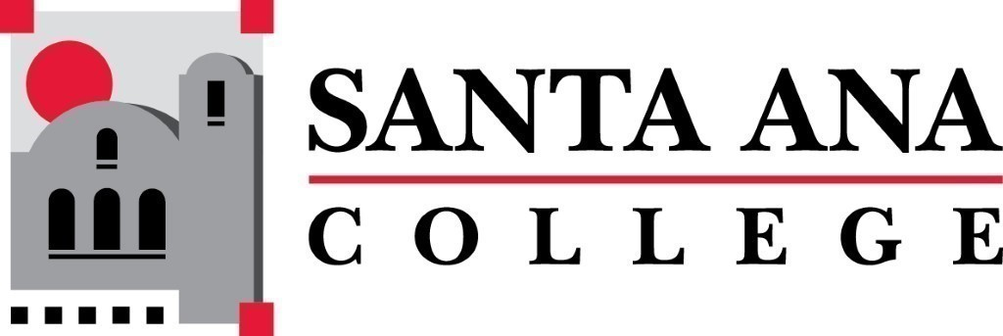 | SAC Program Review Committee  December 6th, 2021  1:00p.m. – 2:00 p.m.  Zoom: https://cccconfer.zoom.us/j/98464779860
- Introductions and Welcome –Brenda & Jaki
- Approval of November 1st, 2021, Minutes
- Announcements:
  - Amount of completed 4-year reviews (Jaki)
  - Do we allow Zoom presentations, recorded videos?
- Assess Annual and 4-Year template (see attached in meeting invite)
- Assess Rubric (see attached in meeting invite)
- Spring 2022 Professional Development Workshops:
  - Wednesday - 2022 4-year PR training
  - Wednesday - Spring presenters, overview workshop
- Proposed Spring Program Review Meetings Schedule: Mondays, 1pm - 2:30pm, Holidays: Feb 21st and May 30th
  - Feb 14th
  - March 7th
  - March 21st
  - April 11th
  - April 25th
  - May 9th
  - May 23rd

