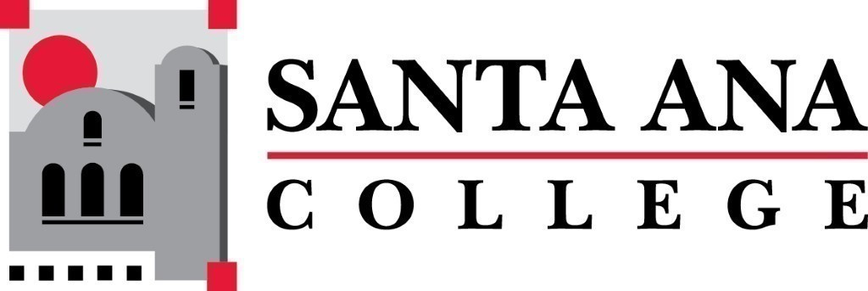 | SAC Program Review Committee  November 1st, 2021  12:30p.m. – 1:30 p.m.  Zoom: https://cccconfer.zoom.us/j/91384625284
- Introductions and Welcome –Brenda & Jaki
- Approval of October 4th, 2021, Minutes
- Action: 2021/2021 Goals Restructure:
  - See Goals document in Nov. 1st meeting invite
  - Note from Tyler Johnson: “Activities are the products (workshops), outcomes are what we measure and track from the activities, and goals are the long-term impacts”
- Fire Technology Request:
“On behalf of the Fire Technology Department and the Department Co-Chairs Kris Ross and Jennifer Meloni: We would like to formally request an extension to complete our Program Review. We request that an extension be granted until the Spring semester of 2022. This should give the department and the chairs sufficient time to develop a plan and a timeline for completing the Program Review. Respectfully, Kris Ross, M.A.
- Discussion – Closing the Assessment Cycle (Rubric/Presentation):
Rubric and presentations are now on PR website.
Ideas: Round table, facilitated discussion instead of a “presentation” with more than one program/service area present at a time.
Multiple programs/service areas contribute to rubric, the committee facilitates assessment as opposed to being the only ones providing it.
- Accreditation Update (see attached pdf in meeting invite):
The first core inquiry states, “The team seeks to better understand the implementation of improvements/redesign to systems for assessment and program review that support resource allocation.” This core inquiry seeks clarification on whether the college meets the four standards listed and addressed by this core inquiry.
- Study Session Wrap-up
- Meeting Schedule:
  - Monday, December 6th 1pm-2pm

