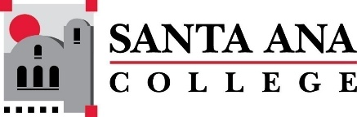 |  | Minutes: SAC Program Review Committee  May 9th, 2022  1:00p.m. – 2:30 p.m.  Zoom: https://cccconfer.zoom.us/j/95559225327
Committee Members Present: Jaki King, Kim Smith, Saeid Eidgahy, Dr. Walter Jones, Kathy Walczak, Cherylee Kushida, Stacey Bass, and Catherine Emley.

Guests: Nicholle Clark, Rodrigo Valles, Steve Bautista, Tanisha Burrus, Stephanie Clark, Leo Pastrana, Armando Soto

Introductions and Welcome

The minutes of April 25th, 2022 were approved unanimously. Moved: Walter Jones and Second: Saeid Eidgahy

Presentations:

Older Adults – Nicholle Clark presented.

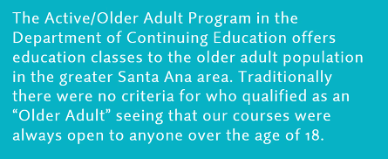

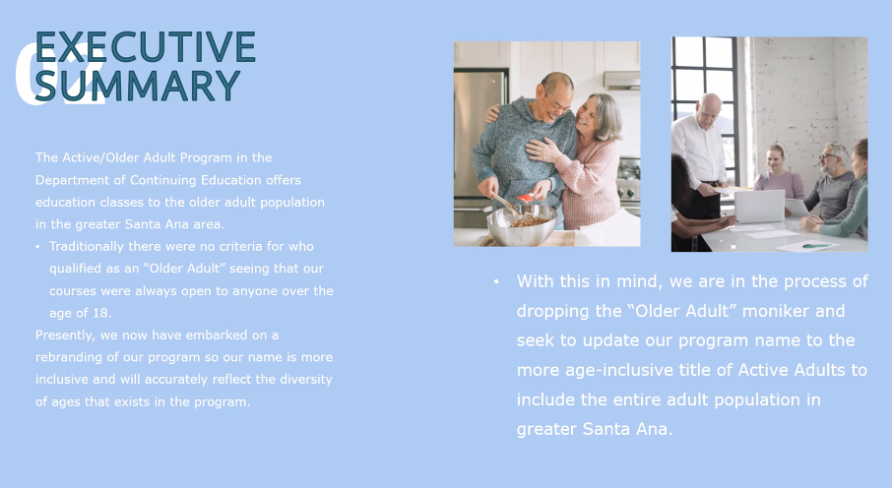

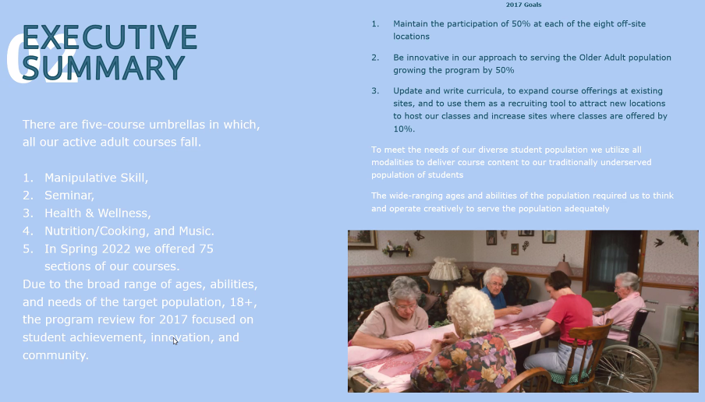

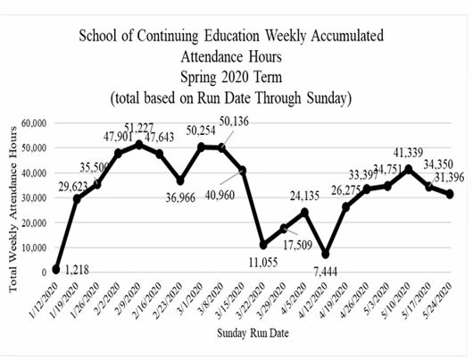
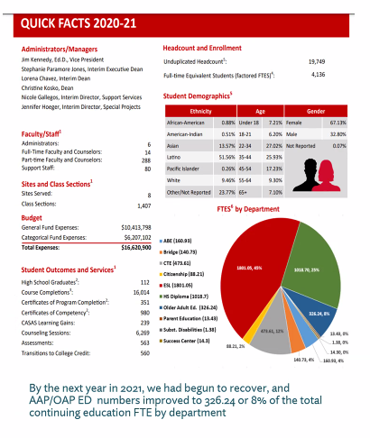

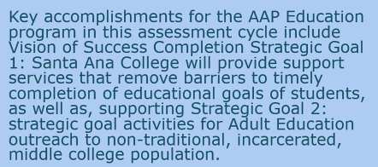

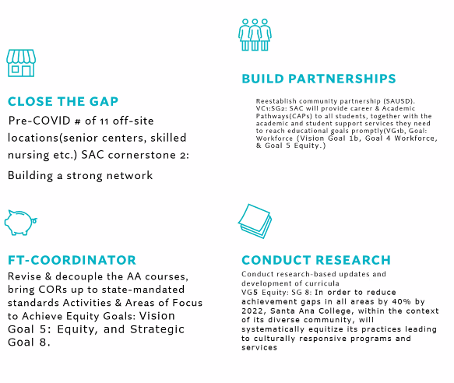

Facilitated Round Table Discussion:

1:25pm –2:30pm Ethnic Studies, Center for Teacher Education, Digital Media (Rodrigo Valles, Steve Bautista, Stephanie Clark) were introduced. Note each are referenced below by either department, or their own, initials.

Guided questions and discussion:

What challenges did your program or service area overcome or are still tackling?

CTE: Department went from a fully to less than fully funded program. In the Fall 2021, SS Coordinators were institutionalized after 22 years, which was a long wait.

DM: Stephanie reflected on digital media creation, developed some dual enrollment pathways, and relationships with the DMC. Areas that are still being worked on include documentation of SLOs. Administrative decision-making and support. Scaling dual enrollment. Development of cohorts because of off-site instruction, which is an area they do not have expertise in and are looking for such.

ES: Campus politics presents a struggle. Area F progress has been made, however, now encouraged not to expand.

What were your prior or past goals? Summarize if they have been met, changed, or if the program was unable to complete.

DM: Goals have been achieved. Graphic Design and Digital Media have merged. Website revamp, marketing profiles, agency film production was developed,

CTE: Identification of students who would like to be secondary school teachers when they begin community college. PLOs have been fuzzy however grant goals provide significant guidance. Particularly those that relate to strong workforce. Difficulty of using data to connect program to degree completion.

ES goals have been mostly completed. Certificates/area F issue was a hinderance. Internal politics were again cited.

How has “Guided Pathways” and/or “Equity Minded Practices” affected your program or service area?
In what ways, if any, has your program/service area collaborated with other programs/services on campus? Are there additional areas of collaboration that could be beneficial?

ES: Not really. Pathways did not do much to help. Neither has counseling.

CTE: Guided pathways has benefited this program. Starfish has been helpful to identify students who will continue on to become teachers.

DM: Stephanie suggested that RV look into the future educators' CAP for some guidance as they have done an excellent job. Engaging in CAP activities, develop opportunities related to counseling and enrollment.

Rodrigo discussed being a one-person department creates difficulties. Steve discussed ethnic studies as a department that all students will move through. Stephanie recognized student centered decision making as being important.

Rodrigo: part of GE cap, willingness to build classes, use of Learning Center, and openness to collaborate.

Steve: By virtue of location, Center for Teacher Education does a lot of collaboration. Interested in cross-department collaboration.
Rodrigo: How about a ethnic studies credential? Looking forward to a more open and unified campus.

DM: Stephanie developed a 12-unit graphic arts cert, in collab with Samuelli Academy. All 12 units are major transfer. Development of programs beyond the campus.

Is there an element of the college that you as a program or service area wish you knew more about or was better communicated?

Are there missed opportunities to market their programs? Going out to community fairs was suggested by Rodrigo. Steve credited Outreach. Marketing, another department, where services could be expanded upon. Cherylee promised to make a video on how to use Canvas Commons to create a module that discussed different certificates within a division. This may help departments with enrolments. Stephanie discussed how helpful it is to have community partners who use Canvas. Rodrigo discussed inmate coursework. Steve pointed out this group is a special population and therefore gets a higher reimbursement rate. Armando discussed a grant application, and Project Rise. Armando asked about connecting with Rodrigo to engage on an advisory committee.

What have you learned from completing your current 4-year review and what do you hope to accomplish in the next four years?

Rodrigo appreciated the progress that program review has made. Wants us to do things with this information.

Stephanie referenced a lack of completion and desire to improve in those areas. Interest in cohort model.

Steve closed on outcome data being helpful. Referenced a recent graduate and the successful recognition of her on multiple levels. Orange County Teachers of the Year

The meeting concluded at 2:31.

Upcoming Program Review Meeting Schedule: Mondays, 1pm - 2:30pm
May 23rd

Respectfully recorded,
Kim Smith, Esq.

