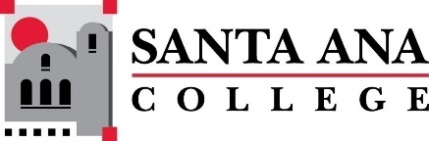 |  | SAC Program Review Committee  April 25th, 2022  1:00p.m. – 2:30 p.m.  Zoom: https://cccconfer.zoom.us/j/95559225327
Committee Members Present: Jaki King, Kim Smith, Kathy Walczak, Saeid Eidgahy, Catherine Emley, Cherylee Kushida, Dr. Brenda Estrada, Dr. Fernando Ortiz, Dr. Water Jones, Kyle Bradley
Guests: Nicholle Clark, Leann Alduenda, Kristen Nelson, Nicole Patch, Annie Knight, Heather Gillette, Kyle Wendy Wang, Dawn McKenna-Sallade, Christine Kosko
Introductions and Welcome: Jaki welcomed us to the meeting.
The minutes from April 11th, 2022, were approved unanimously. Catherine moved and Kathy Walczak was the second. All approved.
Presentations:
Nicholle Clark presented for Parent Education – Parent Education is part of the Health and Safety Department, OAP/Active Adults. Ms. Clark is an adjunct or part-time employee of the college. Ms. Clark noted the dearth of research and resources in her department, which are necessary to eventually lobby the school for a full-time program coordinator for this non-credit program. Her presentation covers the following topics:
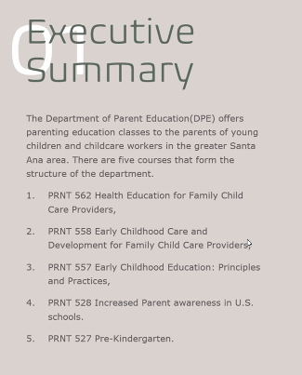

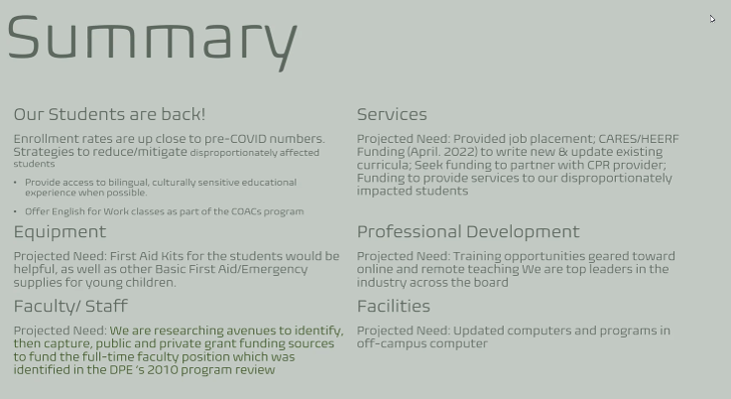
Facilitated Round Table Discussion:
1:25pm –2:30pm Dance, Library, Occupational Studies (Heather Gillette, Leann Alduenda, Annie Knight, Susan Hoang, and Dawn McKenna- Sallade)
- Introductions: Wow what an incredible introduction by the Dance Department. It set the tone for the entire round-table discussion. They danced it!

Question: What challenges did your program or service area overcome or are still tackling?
- Dance: Course repeatability and skills base approach for Dance is so important. Marketing help is needed to strategize to build a stronger presence, FPA director to support because they are so tired of failing because of courses cancelling so often. They need to be heard and seen. Support for rebuilding. Does guided pathways steal students away? They are tired, students are tired of hearing they are not worth it.
- Library: Huge Covid impact. Staff/colleagues have been so important to surviving this period. Hybrid service model that could improve with additional staffing.
- OTA BA program: Dawn McKenna-Sallade presented. The first BA was 2019, covid numbers were down as most worked in health care, so job loss or mandatory front-line work had an impact. 23 to 15 to 19, and now at 11 graduating. Part time and covid impact.
Question: What were your prior or past goals? Summarize if they have been met, changed, or if the program was unable to complete.
- Past goals achieved: Library has successfully integrated technology to support remote and in-person needs. 24/7 support through a co-op relationship. There have been many website improvements. They have now have remote appointments with students available. Dance reported out on transition of goals. OTA experienced a bulk of students who returned for BA program, now transitioning into goals related to program improvement and student education. OTA and writing, plagiarism.
- Annie Knight discussed plagiarism to Occupational Therapy so that library can support. (idea: writing professional reports, etc. Could be a collaboration project for the Learning Center.)
Question: How has “Guided Pathways” and/or “Equity Minded Practices” affected your program or service area?
- Equity Practices: Hybrid/online learning curve was a challenge. Wendy Wang discussed how she uses in person now more to support online skills. Annie Knight talked about INFO 100 being paired with other disciplines to ensure the curriculum is meeting other needs across the college. Revamp on librarian liaison model to pursue a change into a guided pathway model of alignment. Dance has been hurt and it is a huge problem for skills based major. (Need: competency-based education, repeatability). They expressed that this is an equity issue because non-resource limited students could seek outside assistance, and not every student is getting the same experience.
- Data says that students trying to audition for a dance major are not meeting standards. They do not have the technical skill set. They need to be able to repeat courses.
- Repeatability is a title 5 issue, says Dr. Ortiz
Question: In what ways, if any, has your program/service area collaborated with other programs/services on campus? Are there additional areas of collaboration that could be beneficial?
- The library has been working with SCC more over the past few years, especially around curriculum development and public service models. How can we take what we have learned and create a hybrid service model needed for distance education students? Occupational Therapy offered that their plate was full regarding collaboration. Dance: Leann, talked about how they put on shows in collaboration with theatre, digital arts.
Question: Is there an element of the college that you as a program or service area wish you knew more about or was better communicated?
- Budget, per Annie Knight. For example, getting quotes for needed equipment. Things get stuck at a certain level. More transparency is needed for those processes. PA system was a good example. Occupational Therapy: feels like they stumble across problems and discussed the need for localized information. Students fall into your lap with a problem, and it can be a struggle to know where to send the student. Problem solving is mostly relationship based, which can be to catch what you can. Dance did not realize there was an outreach department. Now she does. What is the process and who do you contact? More communication and an easier way to find college resources.
- Kim put librarians on the spot. They suggested a searchable intranet. It is doable, we just do not have it here at SAC. Effective usable tools, searchability. Faculty empowerment was also identified as a suggestion.
Question: What have you learned from completing your current 4-year review and what do you hope to accomplish in the next four years?
- There was lots of support for this new model from participants and committee members. Dance appreciated that they were able to see common themes.

Upcoming Program Review Meeting Schedule: Mondays, 1pm - 2:30pm, Holidays: Feb 21st and May 30th
- May 9th
- May 23rd

The meeting adjourned at 2:30 PM.
Respectfully recorded,
Kim Smith, 4/25/22

