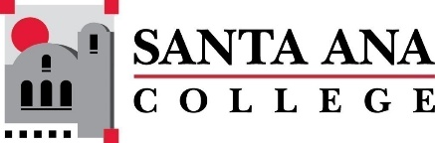 | SAC Program Review Committee  March 07, 2022  1:00p.m. – 2:30 p.m.  Zoom: https://cccconfer.zoom.us/j/95559225327

Minutes, Program Review Committee, March 7, 2022
Committee Members: Kim Smith, Cristina Gheorghe, Jaki King, Saeid Eidgahy, Cherylee Kushida, Catherine Emley, Dr. Walter Jones, Dr. Brenda Estrada, Kathy Walczak, Kyle Bradley
Guests: Leo Pastrana, Courtney Beine, Madeline Grant, Craig Takahashi, Gerry Contreras, Maria Dela Cruz, Vanessa Orozco-Martinez, Stephanie Clark, Ann Lockhart, Diana Ramirez, Natalie Rodriguez, Courtney Beirne
Introduction and Welcome
Minutes of February 14th, 2022 were approved unanimously. Saeid Eidgahy moved, with Cherylee Kushida as second.
Presentations:
1:05PM- 1:20PM Engineering Presentation – Craig Takahashi presented for the department.
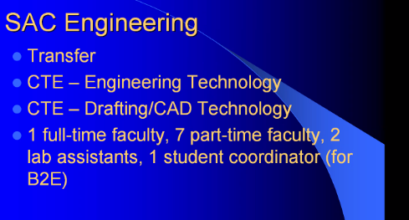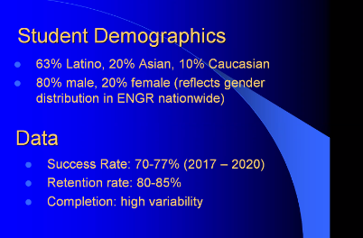
- 91% success rate on SLO data.
- Gender demographics are disproportionate to SAC student population, however consistent with nationwide data for gender in engineering fields.
- Placement within CTE is preferred
- Requesting a lab assistant
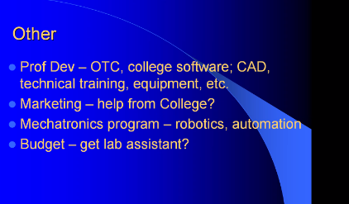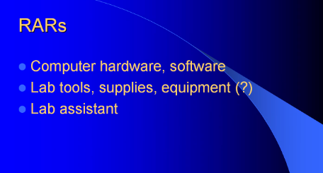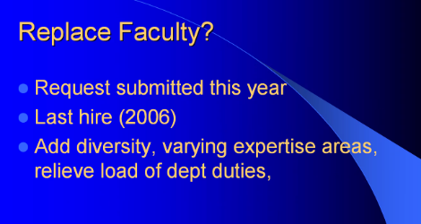

- Jaki questioned about capturing data of students who are not intending to graduate, perhaps just here for professional development. Craig suggested that survey is only successful strategy he has developed. Perhaps WebAdvisor, or other resource such as Starfish could be one day used. Another idea is a mandatory survey before a student can progress, drop, etc.
- Madeline commented on curriculum that Craig has revamped and moving the department into the new Science Bldg. Both responsibilities have fallen on Craig. He really needs assistance in the form of staff. Madeline also discussed B2E perhaps becoming a model for the Pathways or departments. Computer Science for example.
- Catherine asked about the number of students in the department. 300 or so per semester was the answer. Could a lab assistant be shared with another department?

1:20PM-1:35PM University Transfer Presentation – Leo Pastrana presented and introduced and faculty within his program. Below is a description of the programs:
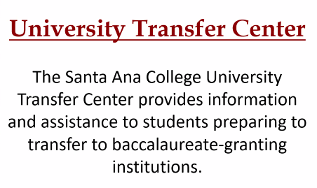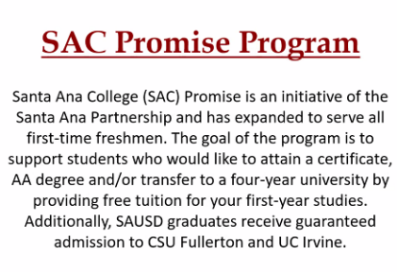

- Pre/post COVID activities, such as the Northern Trip, have changed.
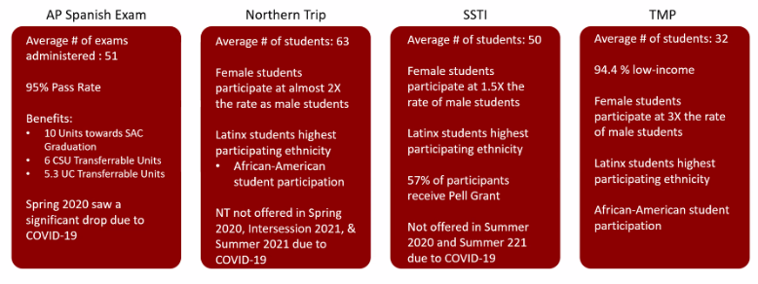
Difficulty with showing a clear demographic profile. More women than men in programs. Fewer African Americans.
- SAC promise Program is huge. 2,887 students. Communication with students is a huge struggle.
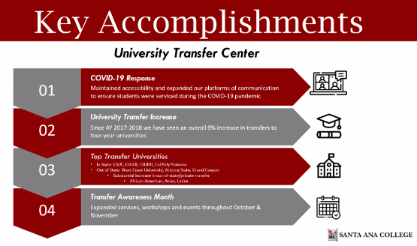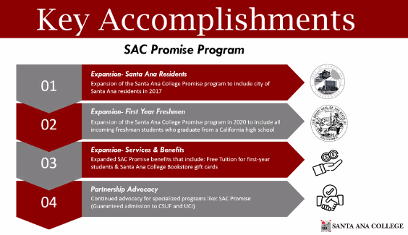
- 4% increase in transfer rate.

1:40PM-1:55PM ULink Presentation – Courtney Beirne presented. ULink is housed with the University Transfer Center.
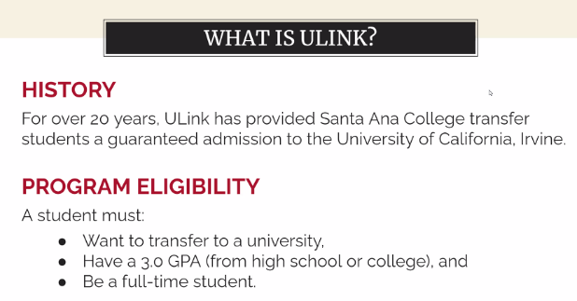
100 hours of service learning is required. 2021 was cancelled because of COVID. 2022 the hours have been adjusted.
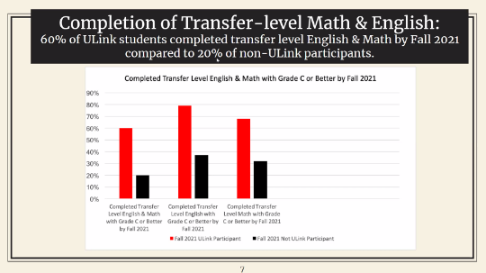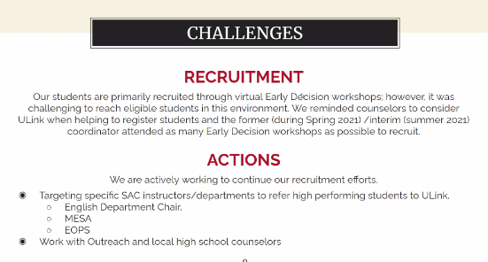
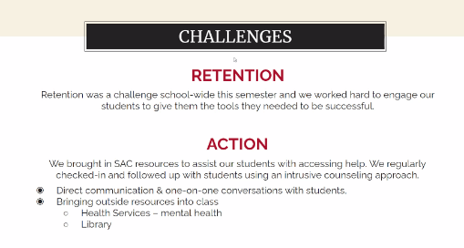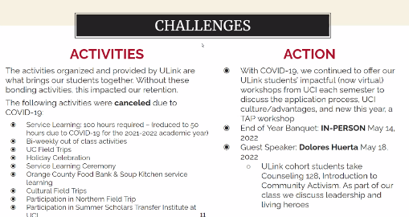
- Kathy Walczak discussed how the Learning Center has appreciated having ULink students doing their student learning obligation there. She also suggested that ULink participate in SAC days.
- Participation in the Career Exploration Events may be likewise helpful. Contact Stephanie Clark for additional information. Cherylee suggested that SAC faculty could know more about ULink. Catherine suggested that visiting division meetings might be a strategy to do that.

Announcements and Reminders - Accreditation Interview is 11am-11:50 on March 8th.
- IEPI meeting is scheduled for March 24. Saeid discussed the IEPI, partnership resource team, and gave us some background.
- Round Table Discussion Document. April 24. Jaki put together some information for the committee to review on what points the committee may want addressed.

2:15PM-2:30PM History Presentation – Moises Medina
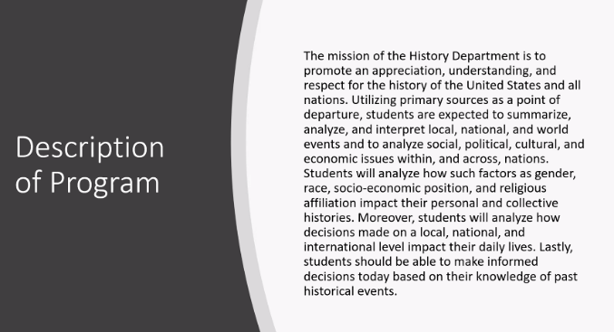
- 26 courses are offered. AA and AAT are offered. Enrollment has remained stable, however Spring 2020 and 21 required the cancellation of several sections. A review of course offerings resulted in more consistency in the schedule. The history department faculty has also stepped up to participate in and support campus events to be more visible on campus. Coordination with the Learning Center has also increased.
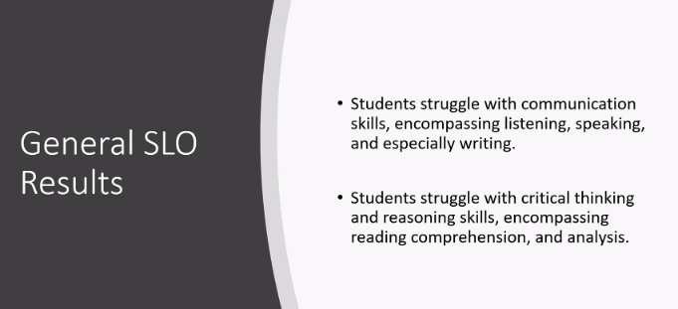

- Walter discussed dual enrollment opportunities for the department. There is concern in the department that high school students may not be able to handle the rigor of a college history class. Jaki discussed the library collection of Santa Ana history, and perhaps the History Club may want to take part in digitizing or managing the collecting.

Upcoming Program Review Meeting Schedule:
Mondays, 1pm - 2:30pm, Holidays: Feb 21st and May 30th
March 21st
April 11th
April 25th
May 9th
May 23rd

Meeting Adjourned 2:30PM.
Respectfully recorded, Kim Smith

