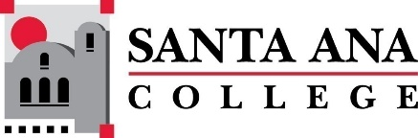 |  | SAC Program Review Committee  February 14, 2022  1:00p.m. – 2:30 p.m.  Zoom: https://cccconfer.zoom.us/j/94946658660
Members: Jaki King, Saeid Eidgahy, Kathy Walczak, Catherine Emley, Dr. Brenda Estrada, Stacey Bass, Cherylee Kushida, Cristina Gheorghe, Dr. Walter Jones, Kyle Bradley, Matthew Beyersdorf
Guests: Amberly Chamberlain, Patrick Dibb
Introductions & Welcome: Jaki reported to the group the availability of a book (with the assistance of professional development funds) for program review committee members to pick up. Members can contact Christopher Sandoval to either schedule a time to pick up OR to have the book placed in your mailbox. Book title: Creating a Data-Informed Culture in Community Colleges: A New Model for Educators.
Approval of December 6th, 2021, Minutes: Dr. Brenda Estrada moved to approve, Cherylee Kushida seconded. All in favor.
Announcements:
Jaki reported the great news that all but one program/service area have turned in their 4-year program review or have made a successful request for extension. Kinesiology will need to turn in a formal extension request for their “Athletics” 4-year review.
Brenda gave an update about the accreditation process. A document has been shared with the committee about the Core Inquiry #1 (which is about the Program Review process). Any feedback or comments can be added to the document or forwarded to Dr. Estrada or Jaki King. The accreditation team will be asking to talk to the program review committee.
4-Year Review Presentation – Library Technology, Jaki King:
- Library Technology program has students throughout the state.
- More women than men as is consistent throughout history of library.
- Although LT program at SAC has more Hispanic or Latinx students than any other demo, white students make up the next largest demographic.
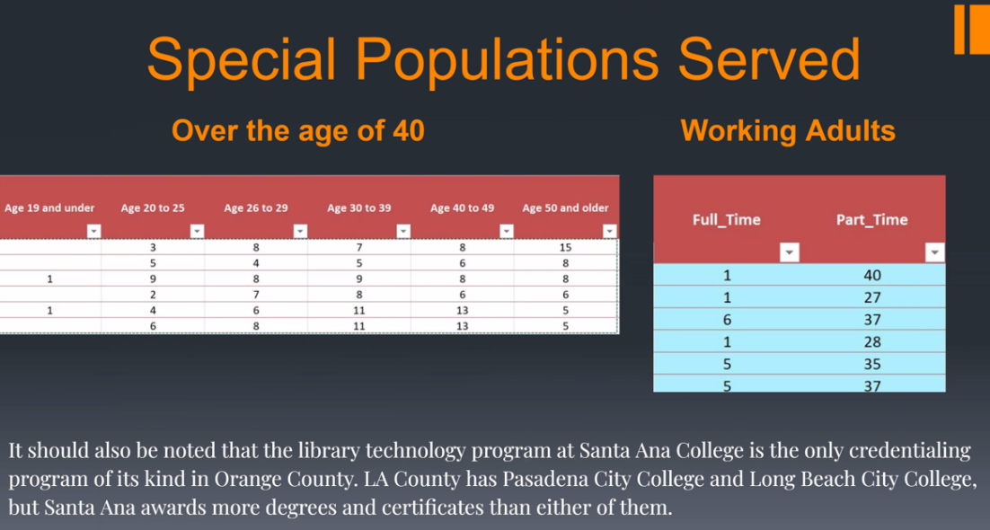
Goals include:
- Providing equitable and high-quality courses for all students.
- Focus on getting “Quality” badged through California Virtual Campus (CVC).
- Participate in continual and meaningful assessment.
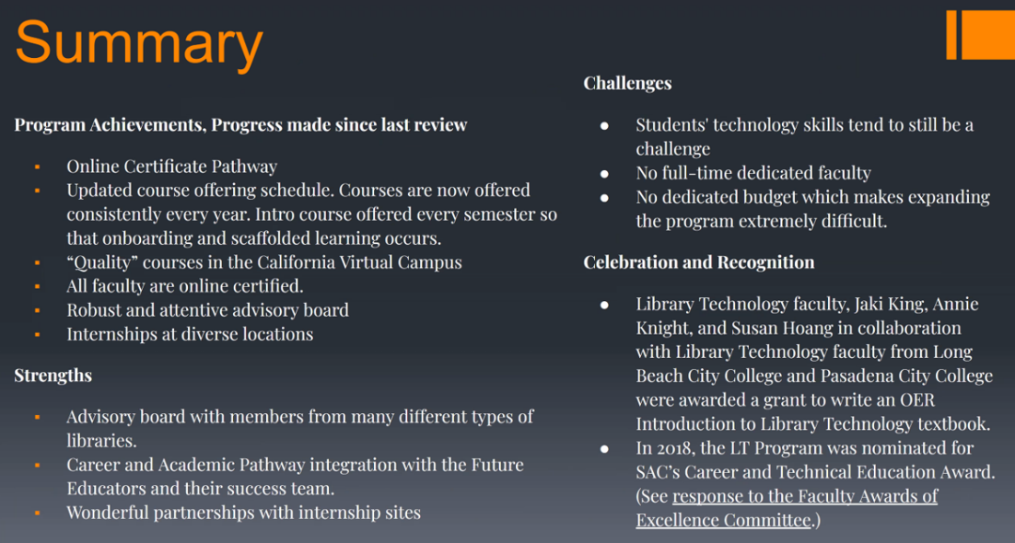
Library Tech Presentation Notes:
- Library, library tech certificate, Information studies, are not the same thing.
- A discussion about RARs ensued. It was suggested that the library technology program begin submitting yearly RARs.
- Cherylee asked if there was a way to quantify how many of our students are outside of Santa Ana, the county, etc.
4-Year Review Presentation – Emergency Medical Technician (EMT), Patrick Dibb:
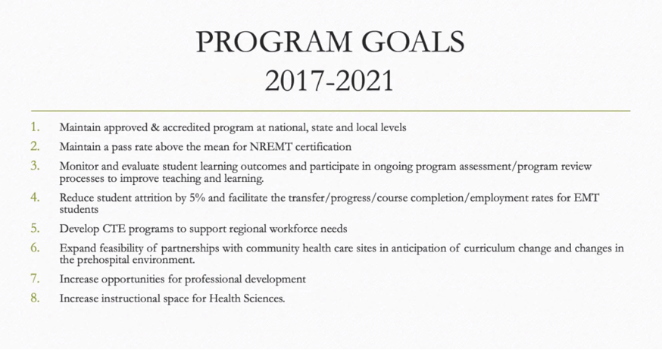
EMT Presentation Notes:
- Under Science, Math and Health Sciences, works under Nursing Dept.
- EMT classes are 10 or more units.
- Classes are based on statutory requirements at both the state and federal (sometimes even local) that establish a scope of practice.
- 20-29% growth by 2024
- EMT requires that students take a national registry test. NREMT is the organization that runs the test.
- Strict background test
- Goals are below on slide:
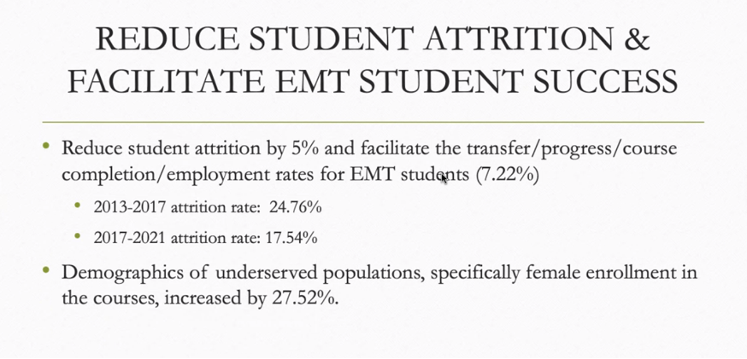

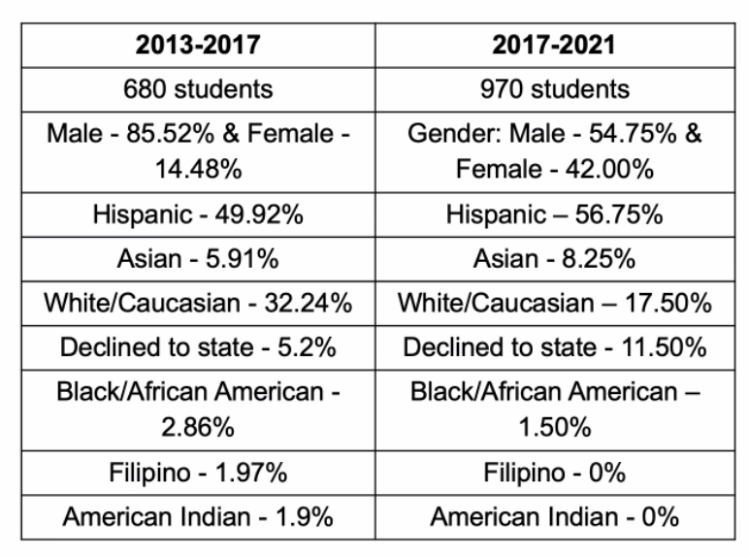
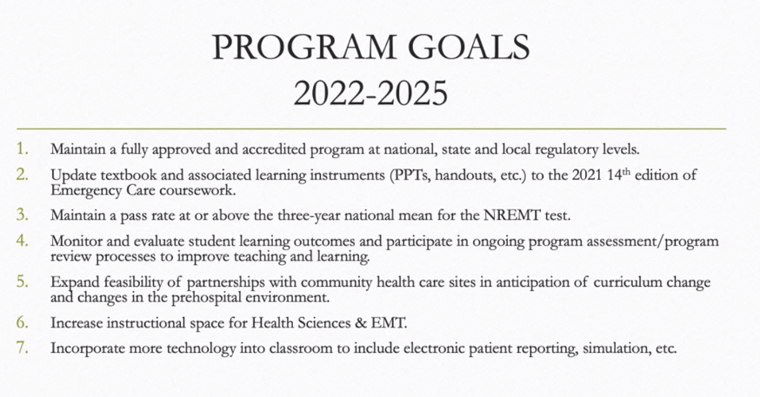
COVID has had some impact on internships and classroom learning.
Round Table Discussion (Pilot) Development:
April 25th we have our first pilot group, consisting of Library, Dance, and Occupational Studies.
May 9th is our second pilot group, consisting of Center for Teacher Education, Ethnic Studies, and Digital Media.
Jaki created a shared doc on the Program Review team’s site. Please add potential questions, comments, or procedures to the document. We will discuss it at a later meeting.
Committee Membership Document:
Jaki shared a document about the program review membership. Updated to remove Becky Ettinger (they are on leave) and added research department representative, Cristina Gheorghe. Will send the document to Jim Isbell (Academic Senate).
Reminder:
There will be 4 presentations at our next meeting so all presentations will need to be timed exactly. There cannot be any presentations going over their allotted time.
Upcoming Program Review Meeting Schedule:
Mondays, 1pm - 2:30pm, Holidays: Feb 21st and May 30th
  - March 7th
  - March 21st
  - April 11th
  - April 25th
  - May 9th
  - May 23rd

