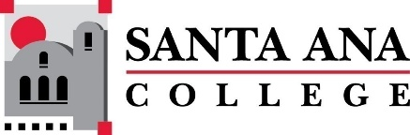 |  | SAC Program Review Committee  February 14, 2022  1:00p.m. – 2:30 p.m.  Zoom: https://cccconfer.zoom.us/j/94946658660
- Introductions and Welcome – (Brenda & Jaki) - 5 min
- Approval of December 6th, 2021, Minutes – 5 min
- Announcements - 5 min:
  - 4-year reviews completed/those unfinished (Jaki)
  - Accreditation Overview (Brenda)
- 1:20PM- 1:35PM Library Technology Presentation – Jaki King
- Round Table Discussion (Pilot) Development – 25 min
  - Two pilots, April 25th and May 9th with:
    - Library, Dance, and Occupational Studies &
    - Center for Teacher Education, Ethnic Studies, and Digital Media
  - Action Item: Develop a facilitation plan (questions, process, procedures)
    - Shared teams doc
- 2:05PM-2:20PM EMT Presentation – Patrick Dibb
- Further Round Table Discussion or Announcements – 10 min
  - Spring 2022 Professional Development Workshops
  - Committee Membership Document – verify correct
- Upcoming Program Review Meeting Schedule: Mondays, 1pm - 2:30pm, Holidays: Feb 21st and May 30th
  - March 7th
  - March 21st
  - April 11th
  - April 25th
  - May 9th
  - May 23rd

