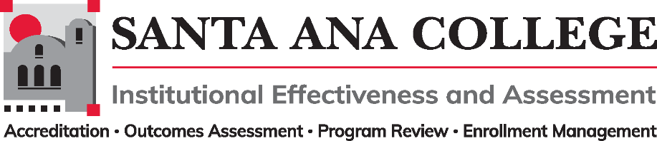
Minutes
May 4, 2022
2:00 – 3:00pm
Zoom- https://cccconfer.zoom.us/j/93732271856

Santa Ana College Mission: Santa Ana College inspires, transforms, and empowers a diverse community of learners.

Santa Ana College Vision Themes: I. Student Achievement; II. Use of Technology; III. Innovation; IV. Community; V. Workforce Development; VI. Emerging American Community

Voting Members Present: Dr. Fernando Ortiz (co-chair), Justin Tolentino (co-chair), Dr. Vaniethia Hubbard, Dr. Saeid Eidgahy, Tyler Johnson, Kim Smith, Ashly Bootman, Suzanne Freeman, Andrew Barrios,

Ex-officio Members (Non-Voting) Present: Monica Zarske, Jaki King, Dr. Jarek Janio

Guests: Heather Arazi, Mary Steckler, Timothy Winchell, Interpreter Nicole Pancino, William Reardon, ASL Interpreter – Liz, Dr. Walter Jones, Cristina Miranda

Dr. Ortiz began the meeting at 2:01

- Introductions and Membership: None

- Public Comments: No public comments

- Action Items:
- Approval of Minutes from April 13, 2022 meeting – Kim Smith and Dr. Eidgahy made motions to approve- Minutes approved as presented.

- Information: No informational topics.

- Discussion:
  - Taskforce Updates
    - Justin Tolentino shared the rough draft of the long-term integrated planning and annual planning documents. Shared that after receiving suggestions from Dr. Nery, the taskforce began to draft a process and have reached out to the chairs of Planning and Budget Committee to get help in aligning work.
    - Justin asked the committee to reach out as the taskforce needs additional participants.
  - Second Read – 2022-2023 Participatory Governance Handbook
    - The revised copy of the 2022-2023 Participatory Governance Handbook was shared and showed edits made by Dr. Annebelle Nery which reflect the use of Brown Act guidelines as “best practice” for all committees listed in the handbook. During the April 13th College Council, Dr. Nery explained that only the Academic Senate falls under the Brown Act.
    - There is a pending edit to SAC Management Association listed under Professional Development. Given that SACMA is dues-paying, it should not live under the PG structure. Teresa Mercado Cota will be sharing and revising the purpose statement with PD members and will be sending the revised version once completed.
    - A recommendation was made stating that Management Council should also vet and provide revisions and feedback to the document.
    - Dr. Ortiz requested approval to the 2022-2023 Participatory Governance Handbook pending the Management PD purpose statement.
    - Kim Smith and Ashly Bootman made motions to approve-2022-2023 Participatory Governance Handbook was approved with pending Management PD purpose statement.

- Subcommittee Reports:

- Outcomes Assessment – Dr. Jarek Janio
  - Dr. Jarek Janio reported on current work being done with ITS and Nuventive. The upcoming meeting topic will be the automated transfer of data.
  - The Outcomes Assessment committee has finalized their goals document and will be sharing to the IE&A committee at the end of the semester.
- Accreditation – Monica Zarske
  - Monica Zarske reported on the Annual Report and ACCJC doing a data analysis on head count changes and institutional growth.
- Program Review – Jaki King/Dr. Brenda Estrada
  - Jaki King shared that she will be the Program Review & Nuventive point person to help with transition and training in the Fall.
  - There has been a pilot program of Program Review presentations & facilitated round table discussions. The committee will be evaluating if this method of presentation will continue
  - Responses shared regarding process:
    - Response 1: I enjoyed this process much more than the power point presentation I gave for the OTA program last year. It was nice to be with other programs and share similar situations. It is also another way to meet other department faculty!
    - Response 2: The guiding questions were very thoughtful and elicited helpful and informative feedback. Perhaps a question could be added about what efforts/progress/accomplishments each department/program is most proud of. I definitely felt heard during the discussion and did feel there was ample opportunity to showcase my program/service area while also having opportunities to raise concerns and questions. I found the conversation overall to be incredibly meaningful while creating a sense of comradery and community among participants. I left the meeting feeling very hopeful and proud of my colleagues. I don’t think any of the guiding questions need to be changed as it provided an open opportunity for everyone to share in a safe space. I feel that everyone was heard and supported in their sharing! The size of the event was “just right” to allow equal opportunities to share and highlight the programs/service areas.
.
- Enrollment Management- Dr. Jeffrey Lamb
  - Dr. Fernando Ortiz shared an IEPI update on behalf of Dr. Lamb – The last PRT focused on team inquiries about CAPs and program mapping, L&E and Nuventive work. The Menu of Options file was shared and is provided as a guide to the areas of focus. Second visit to take place May 5th.
  - Dr. Hubbard commented that Starfish does not have capability of C-4 in the Menu of options.

Next meeting to take place on June 1, 2022
Meeting ended at 2:31 pm

- Upcoming 2022-2023 Meetings – All meetings are the first Wednesday of the month from 2:00-3:00pm unless otherwise noted

June 1, 2022 - September 7, 2022 - October 5, 2022 – November 2, 2022 – December 7, 2022

.

