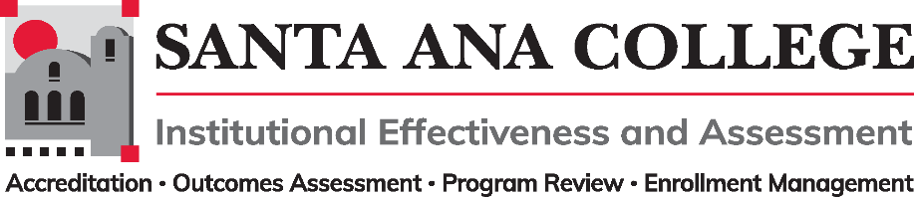
Minutes
March 2, 2022
2:00 – 3:00pm
Zoom- https://cccconfer.zoom.us/j/97210888153

Santa Ana College Mission: Santa Ana College inspires, transforms, and empowers a diverse community of learners.

Santa Ana College Vision Themes: I. Student Achievement; II. Use of Technology; III. Innovation; IV. Community; V. Workforce Development; VI. Emerging American Community

Voting Members: Dr. Fernando Ortiz (co-chair), Justin Tolentino (co-chair), Dr. Vaniethia Hubbard, Dr. Saeid Eidgahy, Tyler Johnson, Kim Smith, Ashly Bootman, Suzanne Freeman, Mike Everett, Andrew Barrios, Monica Macmillen, Rowena Valtairo/Carol Seitz

Ex-officio Members (Non-Voting): Monica Zarske, Jaki King/Dr. Brenda Estrada, Dr. Jarek Janio, Dr. Jeffrey Lamb

Virtually Present: Dr. Brenda Estrada, Timothy Winchell, Justin Tolentino, Dr. Saeid Eidgahy, Alyssa (ASL Interpreter), Heather Arazi, ASL interpreter- Andria, Cristina Miranda, Tyler Johnson Dr. Fernando Ortiz, Andrew Barrios, Dr. Jarek Janio, Carol Seitz, Dr. Vaniethia Hubbard, Mike Everett, Ashly Bootman, Dr. Jeffrey Lamb, Janet Cruz-Teposte, Mary Steckler, Monica Zarske

- Introductions and Membership: Dr. Fernando Ortiz began the meeting at 2:02p.m

- Public Comments:

A. Dr. Fernando Ortiz advocated for faculty representation due to the vacancies in committee membership. Requested to reach out to Jim Isbell for official participation.

- Action Items:
- Approval of Minutes from February 9, 2022 meeting: Dr. Saeid Eidgahy made a motion to approve, Dr. Vaniethia Hubbard seconded.

- Information:

- Discussion:
- Taskforce Updates:
  - Dr. Fernando Ortiz shared that work will begin for the Participatory Governance taskforce, a meeting is in place for March 9th with Ashly Bootman and Andrew Barrios to go over the Participatory Handbook and the committee template.
  - Justin Tolentino shared that a “plans” page has been created for simple accessibility through the Participatory Governance webpage. He will continue to work with Dr. Vaniethia Hubbard and Cristina Miranda to update plans on the SAC webpage and work on guidelines to revise plans to ensure alignment with the SAC goals. Justin mentioned that members for this taskforce are still needed and to reach out to him for details.

- Subcommittee Reports:

- Outcomes Assessment – Dr. Jarek Janio
  - Dr. Jarek Janio shared that SLO talks have commenced and have been addressing the most commonly asked questions. Will be looking into creating an answer repository to have all answers available.
  - Nuventive has changed their interface and data transfers are set for March.
  - ILOs have been approved by College Council
- Accreditation – Monica Zarske
  - Monica Zarske shared that the Accreditation virtual visit will take place March 8th and 9th to discuss the Core Inquiries focused on integrated planning and sustainability.
- Program Review – Jaki King/Dr. Brenda Estrada
  - Dr. Brenda Estrada shared that there are presentations set for March 7th at 1:00pm - Engineering, University Transfer, ULink, and History.
  - The program review committee is meeting with the accreditation team on Tuesday March 8th.
  - Representatives from the program review committee are meeting every other week with Nuventive. There have been improvements on the interface and ease of reporting. Dr. Estrada mentioned that workshops on how to input information are to come in the Fall 22 term.
- Enrollment Management- Dr. Jeffrey Lamb
  - Dr. Jeffrey Lamb shared that the Enrollment Management Subcommittee has served to be very efficient and looking to make a transition to an official committee.
  - Shared that committee would have faculty representation
  - Enrollment Management Plan was approved in the December IE&A and will be sent forward for College Council approval
  - Questions on membership were raised. (Full membership list and plan details can be found here (SAC EM Plan-December 2021 Meeting)
  - Shared details from DEMW which focused on Student Ed Plans, Transcript evaluations, potential registrations for schedules a year out.

Dr. Ortiz thanked the committee Meeting adjourned at 2:50pm

- Upcoming 2022-2023 Meetings – All meetings are the first Wednesday of the month from 2:00-3:00pm unless otherwise noted

April 13, 2022 (2nd Wed), May 4, 2022, June 1, 2022

