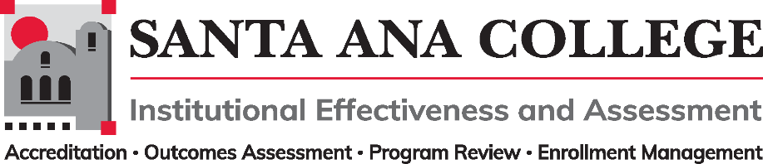
Minutes
February 9, 2022
2:00 – 3:00pm
Zoom- https://cccconfer.zoom.us/j/97210888153

Santa Ana College Mission: Santa Ana College inspires, transforms, and empowers a diverse community of learners.

Santa Ana College Vision Themes: I. Student Achievement; II. Use of Technology; III. Innovation; IV. Community; V. Workforce Development; VI. Emerging American Community

Voting Members: Dr. Fernando Ortiz (co-chair), Justin Tolentino (co-chair), Dr. Vaniethia Hubbard, Dr. Saeid Eidgahy, Tyler Johnson, Kim Smith, Ashly Bootman, Suzanne Freeman, Mike Everett, Jaki King, Andrew Barrios, Monica Macmillen, Rowena Valtairo/Carol Seitz

Ex-officio Members (Non-Voting): Monica Zarske, Jaki King/Dr. Brenda Estrada, Dr. Jarek Janio, Dr. Jeffrey Lamb

Virtual Participants: Andrew Barrios, Ashly Bootman, ASL Interpreter – Liz, Carol Seitz, Cristina Miranda, Dr. Brenda Estrada, Dr. Larisa Sergeyeva, Dr. Vaniethia Hubbard, Dr. Walter Jones, Dr. Fernando Ortiz, Dr. Jarek Janio, Dr. Jeff Lamb, Dr. Saeid Eidgahy, Dr. Timothy Winchell, Heather Arazi, Jaki King, Janet Cruz-Teposte, Justin Tolentino, Juti Seshie ASL, Mary Steckler, Mike Everett, Monica Zarske, William Reardon

- Introductions and Membership: Meeting commenced at 2:05 p.m. and a welcome was given to all for Spring 2022

- Public Comments:

- Action Items:
- Approval of Minutes from December 1, 2021 meeting
  - Dr. Saeid Eidgahy moved to approve, Ashly Bootman seconded. Minutes passed with requested amendment to include virtual participants and the addition of Dr. Brenda Estrada as Ex-officio

- Information:

- Discussion:
- IE&A Goals taskforces
    - Dr. Ortiz shared the College Council approved goal setting template. This template was created to facilitate each Participatory Governance committee in addressing the needs as a college.
    - Justin Tolentino shared plan for taskforces to be created and address the following:
        - Create and outline process to support participatory governance in organization, planning, and goal setting
        - Create process to evaluate and update Participatory Governance Handbook
          - Plans for a template and detailed process to be worked on in the following month, will be looking for participants to help with this taskforce. Ashly Bootman and Andrew Barrios volunteered.
        - Organize college and committee plans to make more visible, accessible, and aligned to college goals
          - Goal is to look for a place that is readily available and accessible for all- will be looking for participants to help with this taskforce. Dr. Vaniethia Hubbard and Cristina Miranda volunteered.
          - Dr. Ortiz commented that you do not need to be a voting member to volunteer. All are welcome to join these taskforces and are hoping to get more classified and student involvement.

- Subcommittee Reports:

- Outcomes Assessment – Dr. Jarek Janio
  - Dr. Jarek Janio shared information on the 9th Annual SLO Symposium. Mentioned it had a great turnout and recordings will be available soon.
  - SLO talks will be resuming and will stay on Zoom
  - Nuventive introduced a new platform and new contract reflecting the upgrade has been approved by the RSCCD Board. Trainings for faculty will be held this spring.
  - Outcomes Assessment, Program Review and Resource Allocation groups meet with Nuventive regularly.
  - Processes for transfer of data between Nuventive, CurriQUNET and Canvas are being discussed.
- Accreditation – Monica Zarske
  - The commission has sent 2 core inquiries:
      - The team seeks to better understand the implementation of improvements/redesign to systems for assessment and program review that support resource allocation.
      - The team would like to learn more about how the college is implementing/aligning with and District-wide sustainability efforts.
    - The Accreditation visit is set for March and visitors would like to meet with Institutional Effectiveness and Assessment, SEAP and Program Review committees. Conversations with the commission will be about improvements.
- Program Review – Jaki King
  - Program Review workshops were held for those that had reviews in the fall and had a great turnout.
  - Can report that almost all service areas have turned in on time.
  - Formal notes to requests extensions to be sent to Program Review committee
- Enrollment Management- Dr. Jeffrey Lamb
  - Dr. Lamb shared that during the District Enrollment Management workgroup, the SCC Senate President presented on a comparison/effectiveness of intersession. The question was presented of are we losing Spring enrollment because of intersession enrollment.
  - Data was presented regarding intersession enrollment and shared on District Enrollment Management Workgroup attachment
  - Shared details of work being done for the possibility of students to enroll at the section level through their online Ed Plan
  - Working on components of contact hour reporting

- Other: Dr. Hubbard shared details on the Cash for Credit Initiative

- Upcoming 2022-2023 Meetings – All meetings are the first Wednesday of the month from 2:00-3:00pm unless otherwise noted
    - Dr. Ortiz mentioned that April, May and June meetings may be in person

Meeting adjourned at 3:00pm

March 2, 2022, April 13, 2022 (2nd Wed), May 4, 2022, June 1, 2022

