Intersectionality, Race, & Social Justice Advisory Group
Academic Senate Update 5/10/-2022
- Initiated dialog around developing a Courageous Leadership Institute & facilitation training program for the New Faculty Institute (Year 3) as well as for training AS officers during PD Weeks.
- Connected with global Guided Pathways & Equity Framework
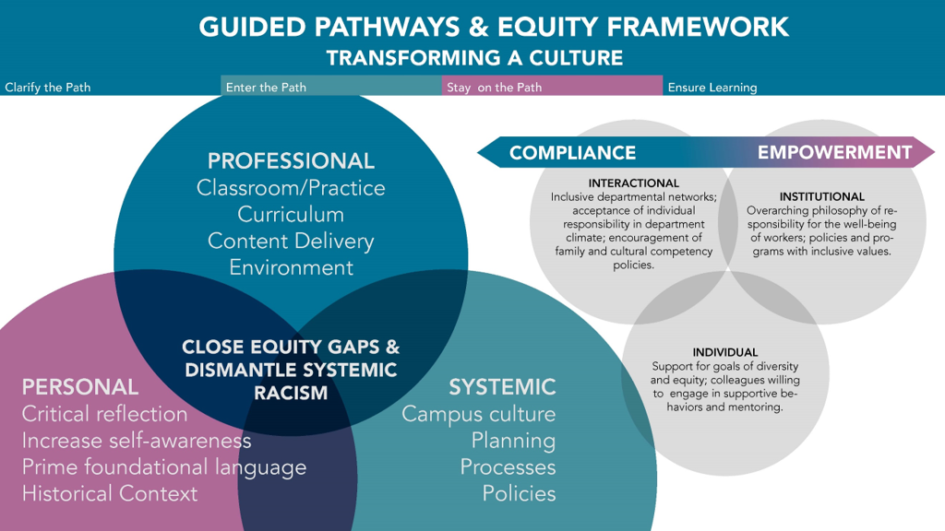
- New Faculty Institute Framework Template Themes Used to Guide Conversation

Year 3: Service & Leadership Training
The systemic involves evaluating, transforming, and designing flexibility in our campus culture, policies, processes, and procedures to support the diverse needs of our students.
OVER-ARCHING YEAR-LONG THEMES
    - Empowerment, Civic Engagement & Ally-ship​
    - Academy of College Excellence with Diego Navarro (FELI)​
    - Courageous Leadership Institute: A focus on equitizing our systems (recommendation by the Academic Senate Racially Inclusive Workgroup)​
    - Professional Showcase – Showcase the transformative practices & creative pedagogy of our new faculty (PD workshops, etc.)​
    - Continue to work with mentor and collaborate with department/division.​
    - Institutional involvement – Assist with placing faculty on Committees, Senate, etc.​
    - Train new faculty as mentors – this will be done within the leadership institute - Begin mentoring year 1 cohort.​ (up for discussion)
Based on the above overarching themes we need to make recommendations for the first-year new faculty institute.

- Initial topics (this are not necessarily individual sessions some of the topics will be merged together): Essentials of effective leadership, Culturally Sensitive Leadership, Access for BIPOC Faculty, Understanding Intention versus Impact, participatory governance and DEI, Navigating Positionality-Power Mapping, Disrupting Unproductive Meeting Practices, Panning, Inclusive and Effective Facilitation, Building Community, Affinity Groups/Ally-ship.
- We will be using a hybrid model that allows for folks to access content/information and remote/in-person sessions will be focused on practice (scenarios, groups/pair activities and/or sharing, etc.)
- This would also be an open series for all faculty (not just new faculty)
- Steve, Annie, Jodi, and Ali volunteered to be part of the core leadership faculty group who helps develop curriculum and
- A proposal needs to be developed and efforts will be connected to the Learning & Engagement Team.
- Recommended that this be discussed at the last May 13th Kathy Obear training for guidance and colleague buy in. There’s also a potential for these institute plans to be part of the outcomes of our Obear training in order to show how we are taking what we learned from the training and invest long-term.

