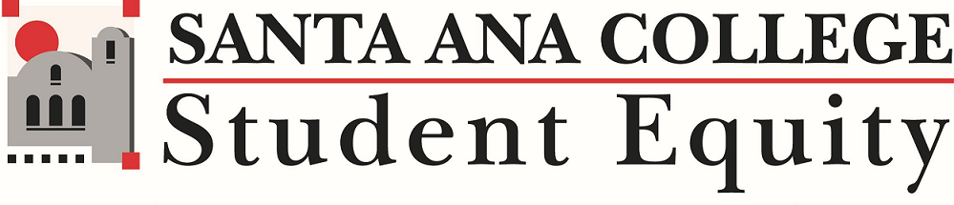

Chantal Lamourelle, Student Equity Faculty Coordinator-Report for Academic Senate on March 12, 2024
https://docs.google.com/document/d/1MBsnVsWTKKFDGYKzSA9xLo5eTHihlAt1mD2zu5SDcco/edit?usp=sharing

- The 2024-2025 SEAP funding request cycle is open. Requests for 2024-2025 fiscal year are due Monday, April 15, 2024. A pdf copy of the completed request form with original signatures must be emailed to miranda_cristina@sac.edu. Late, incomplete, or unsigned applications will not be processed. Hard copies will not be accepted. Questions, comments, or concerns can be directed to Professor Chantal Lamourelle or Dr. Lamb. SEAP Funding Request Open Sessions were held on Wednesday, February 28 and Thursday, February 29, and Wednesday, March 6, 2024 at 1:30 p.m.. Great questions were brought up during the open sessions. We look forward to learning more about upcoming proposed equity focused projects.
- SEAP Funding Cover Page which provides instructions on how to complete the application and supplemental attachments with data and reports that may be used to complete your 2024-2025 Student Equity and Achievement Program (SEAP) Funding Request Form.
- 2024-2025 SEAP Funding Request Form
- SEAP Funding Request Rubric which will be used to evaluate requests.
- On March 7-9, 2024, Two Santa Ana College teams attended the second in person convening at Cal Poly Pomona for the Leading from the Middle (LMF) Academy to work on our year-long projects.
- The SEAP Committee is giving input on the job descriptions for upcoming SEAP Faculty Goal Facilitators and for a Director of Equity and Inclusion to begin to create and build an Office of Equity and Inclusion with dedicated individuals to share in the efforts to close equity gaps on campus.
- Professor Lamourelle will begin to meet on a regular basis with Guided Pathways co-chairs to ensure there is transparent and clear collaboration with the SEAP and Guided Pathways Plans and activities.
- .Professor Lamourelle will be joining the SAC team to attend the final Guided Pathways Intensive on March 20-March 23, 2024.

- On Saturday, March 2,16, and 30, 2024, 100 Black MenOC began their Financial Journey Student Series at SAC presented by JP Morgan Chase.

- 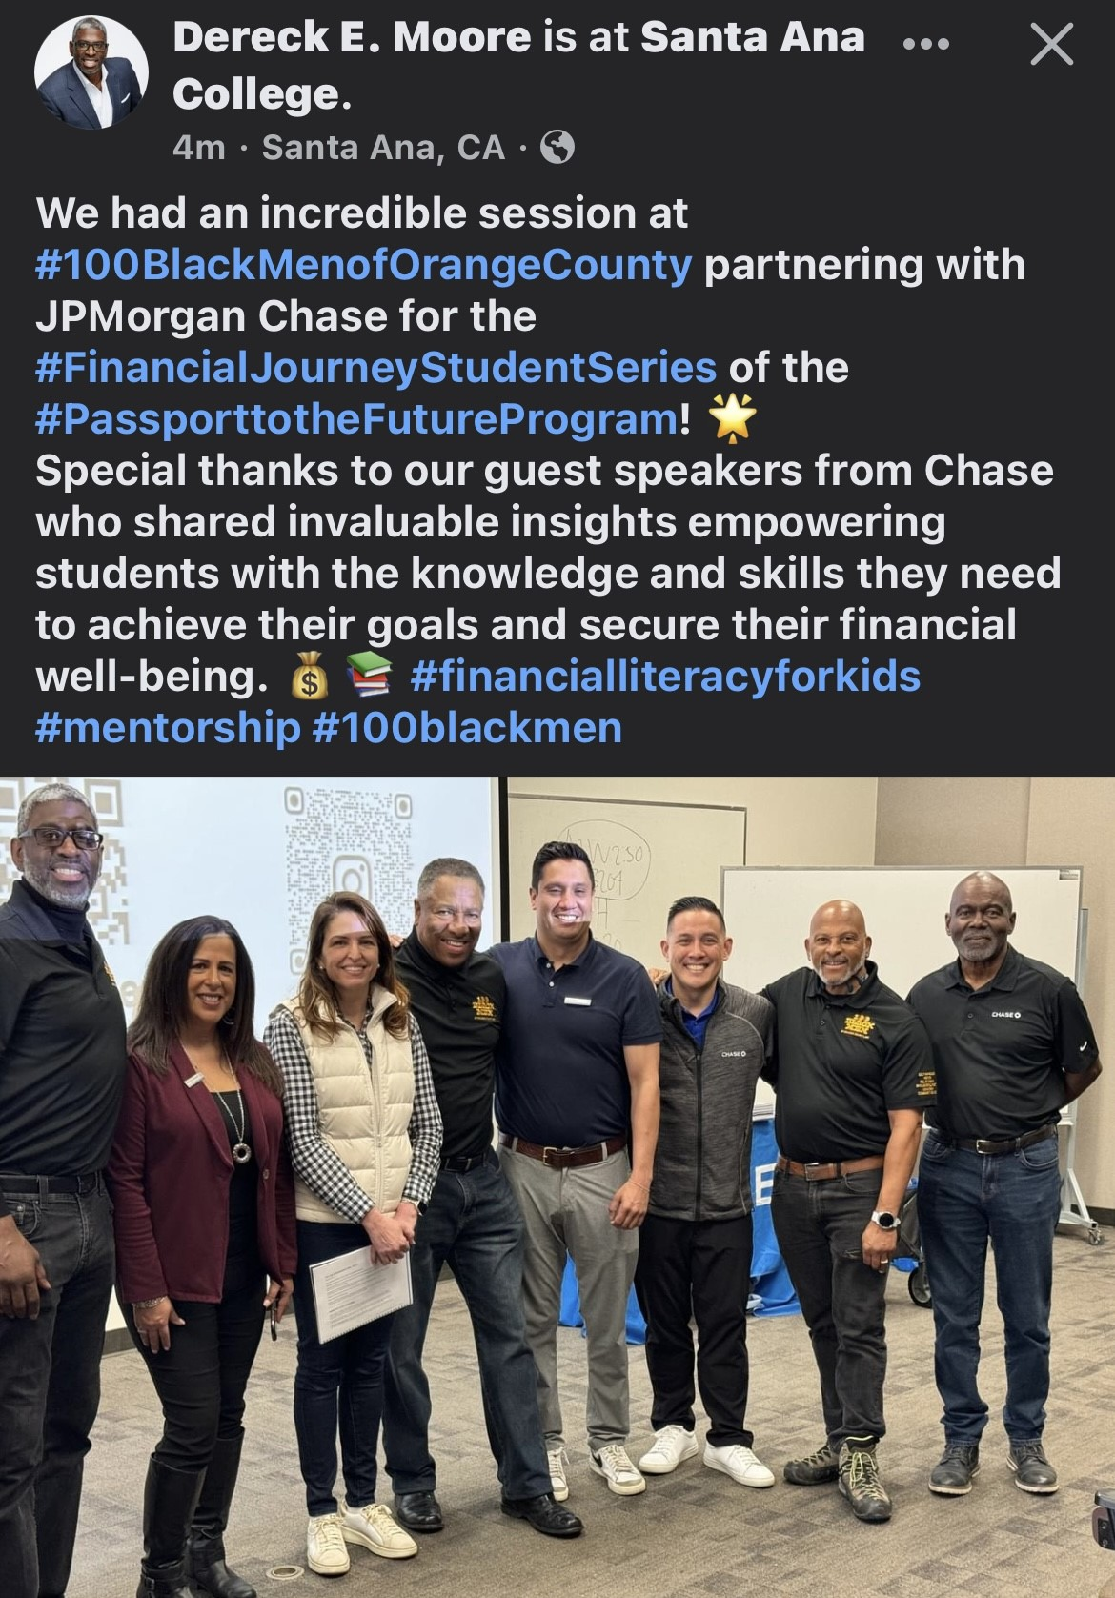

- AB943 Student emergency funds applications were only able to remain open for less 24 hours with 598 students that applied within that time frame. SEAP committee needs one more volunteer for the AB943 Application committee. Contact Professor Chantal Lamourelle, if you are able to participate. lamourelle_chantal@sac.edu.
- Upcoming Meeting: Spring 2023: Thursday, April 4, 2024 from 3-4:30 pm via Zoom
C.Lamourelle ###

