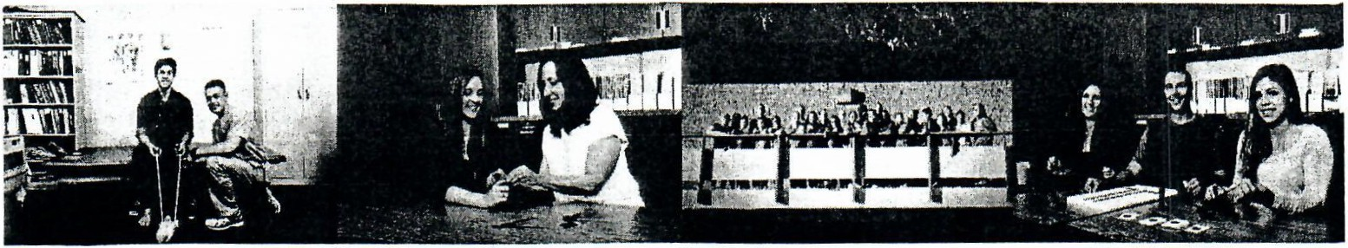

OCUPATIONAL THERAPY ASSISTANT PROGRAM
Michelle Parolise, Program Coordinator

www.sac.edu/ota
(714)564-6833

Occupational Therapy Assistant Degree (0583)
The Occupational Therapy Assistant Program provides a strong foundation in the skills and knowledge necessary for entry-level occupational therapy assistant competencies. The program is accredited by the,
Accreditation Council for Occupational Therapy Education, American Occupational Therapy Association, 4720 Montgomery Lane, suite 200 Bethesda, MD, 20814-3449, Phone Number (301) 652-2682. Graduates of the program are qualified to sit for the national certification examination, administered by the National Board of Certification for Occupational Therapy (NBCOT), 12 S. Summit Ave. Suite 100, Gaithersburg, MD 20877, and Phone Number (301) 990-7979. Students who have completed all requirements will also need to apply for a license to practice in the state of California through the Board of Occupational Therapy (BOT), 2005 Evergreen St. Suite 2050, Sacramento, CA 95815, and Phone Number (916) 263-2294.

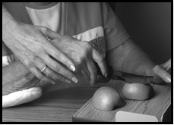
Occupational therapy is a discipline, which focuses on function as well as quality of life. Occupational therapy assistants provide service to individuals with physical, mental or environmental disabilities, across life phases, who need to remediate skills of everyday tasks of work, self-care and leisure. The major requires general education courses including: biological, social, and behavioral science, in addition to, occupational therapy courses. The program utilizes classroom instruction and fieldwork experiences to prepare the student to meet certification and employment standards.

Certified Occupational Therapy Assistants have the opportunity to work in a wide variety of settings including hospitals, outpatient centers, psychiatric facilities, hand clinics, skilled nursing facilities, school districts and private pediatric clinics. The job market in southern California is excellent and is expected to grow. COTA statistics for Orange County, as reported by the California Labor Market 2015, is that the hourly mean wage is $35.70. The job demand is expected to increase by 43.8% from 2012-2022.

Advanced placement in the program for those students with prior occupational therapy assistant education will be evaluated on an individual basis by the program coordinator.

When applying for the certification examination with NBCOT students will be asked to answer questions related to topic of felonies. Finger printing is requirement to apply for state licensure with BOT and for placement in most level II fieldwork sites. For information about limitations based on felonies, students are advised to call NBCOT and BOT any time prior to the application process.

PROGRAM ORIENTATION:
Information Sessions are held one time per month for 8
months of the year. Please refer to website for details.

ADMISSION PROCEDURES:
Apply to Santa Ana College. Download the OTA packet from our website for an application. Submit application and transcripts to the OTA office. Call the Testing Center to schedule an appointment to complete tests.

Completion of the following tests:(Required of all applicants except those that have a baccalaureate degree.) These tests are for purposes of guidance and for establishment that pre­ requisite skills of 101 and 101L have been met.

College Test of English Placement (reading section only) with a minimum score of 25 or above. Students scoring below 25 will be referred to the Student Learning Center.

Santa Ana College Test in Math, Level Ill, showing a total score at 18 or above, or completion of Intermediate Algebra with a grade of "C" or better.

Continued on back…

www.sac.edu ∙ 714-564-6158 ∙ 1530 W. 17th Street, Santa Ana, CA, 92706

FALL 2017/ SPRING 2018

Continued from front:

English 101 or 101L, with a grade of C or better.

Communication Studies (3 units) – Satisfactory completion of Communication Studies 101, 101L, 102, 140, 145.

Biology 149, Human Anatomy & Physiology (4 units) with a grade of C or better. This course has to be taken within the last 10 years.

Psychology 100 or 100H with a grade of C or better. (This is a prerequisite for Psychology 250.)

Applications to the program will be accepted one time per year.

Major requirements for the Associate Degree in Occupational Therapy Assistant:

FIRST YEAR | FIRST SEMESTER | UNITS
O.T.A. 100 | Medical Terminology and Documentation | 1
O.T.A. 101 | Foundations of Occupation and Occupational Therapy | 4
O.T.A. 101L | Exploration of Occupation | 2
O.T.A. 110 | Human Occupation Across Lifespan | 3

FIRST YEAR | SECOND SEMESTER | UNITS
O.T.A. 102 | Psychosocial Function and Dysfunction | 4
O.T.A. 102L | Psychosocial Components of Occupation | 2.5
O.T.A 115 | Human Disease and Occupation | 2
Psychology 250 | Abnormal Psychology | 3
O.T.A. 111 | Applied Kinesiology | 1

SECOND YEAR | THIRD SEMESTER | UNITS
O.T.A. 103 | Physical Function and Dysfunction | 4
O.T.A. 103L | Physical Components of Occupation | 2.5
O.T.A. 201 | Contemporary Models of Occupational Therapy Practice | 4

SECOND YEAR | FOURTH SEMESTER | UNITS
O.T.A. 202 | Level II Fieldwork – Part I | 6
O.T.A. 203 | Level II Fieldwork – Part II | 6

REQUIRED FOR MAJOR |  | UNITS 45

Please Note: Psychology 250 is the only core course that may be taken prior to starting the program.
FALL 2017/ SPRING 2018
www.sac.edu ∙ 714-564-6158 ∙ 1530 W. 17th Street, Santa Ana, CA, 92706
PREREQUISITES | UNITS
Biology 149 | 4
Communication studies 101, 101L, 102, 140, 145 | 3
English 101 or 101L | 4
Psychology 100 or 100H | 3
TOTAL | 14

Additional requirements for the Occupational Therapy Assistant Associate Degree:

Course | Units
U.S. History or Political Science (American Institutions) | 3
Humanities | 3
Cultural Breadth | 3
Communication and Analytical Thinking | 3
Total General Education Units | 12
TOTAL UNITS | 71

*Math proficiency for graduation: Successful completion of the Santa Ana College Math Proficiency Exam or Intermediate Algebra.

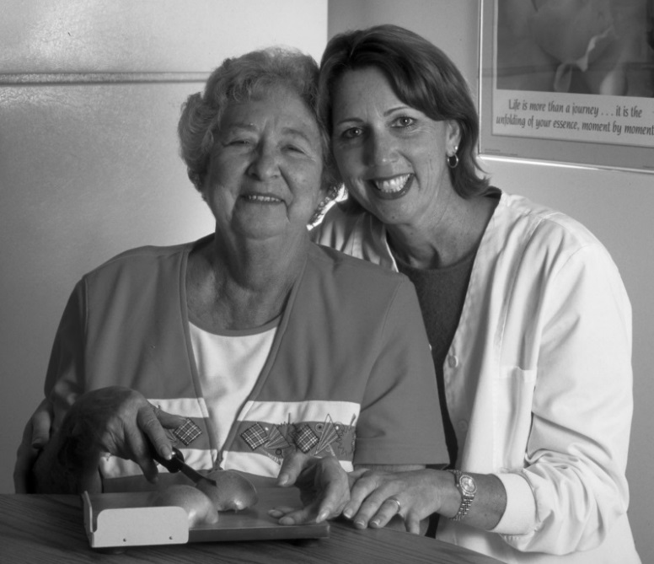

Nondiscrimination Policy
The Rancho Santiago Community College District complies with all Federal and state rules and regulations and does not discriminate on the basis of race, color, national origin, gender or disability. This holds true for all students who are interested in participating in educational programs and/or extracurricular school activities. Harassment of any employee/student with regard to race, color, national origin, gender or disability is strictly prohibited. Inquiries regarding compliance and/or grievance procedures may be directed to District’s Title IX Officer and/or Section 504/ADA Coordinator.
Rancho Santiago Community College District
Title IX Officer and Section 504/ADA
John Didion, Coordinator
2323 N. Broadway
Santa Ana, CA 92706
714-480-7489

