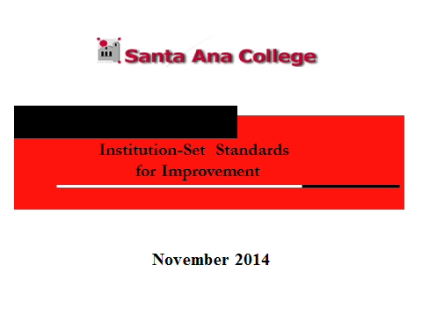

Annotation: Every community college is required to set standards for improvement in five areas: completion, persistence, degrees, certificates, and transfer. The expectation of the Commission is that reasonable goals be established. It is NOT an option to not meet the goals. Every year, in the Annual Report sent to the Commission by March 31st, the College must give an update.

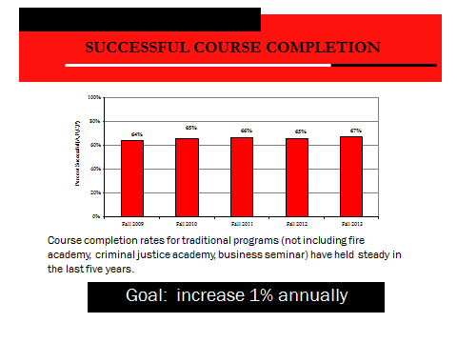

Annotation:
- The baseline utilized should be the mean for the last five years: 65.5% (effective fall 2013)
- Fall 2014 data will be added in February 2015.
- 2% annually is unrealistic, as plans take time to demonstrate a visible effect. A more realistic annual percentage would be 1%.
- In creating strategies and plans, the college could review the highest FTE-producing departments first: English and math, then Fire, Biology and Art.

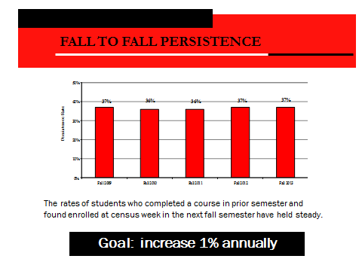

Annotation:
- The baseline is 36.6% effective fall 2013.
- Several issues are being reviewed by the deans and vice presidents in the Enrollment management meetings, e.g., schedule changes, maximum efficiency of room utilization, pathways, set time blocks, etc.
- It is expected the above strategies will enhance retention and successful course completion.

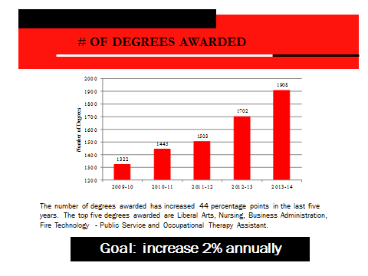

Annotation:
- The baseline is the median of the past five years: 1503.
- 2013-14 data has been added; 2008-09 data has been deleted.
- An explanation for the large increase is the manner in which degrees are configured.
- The increase of the last two years was 12%; there has been a 30.7% increase in the last five years.
- The original proposal of the institutional researcher and the IE&A Coordinator was 10%. This was lowered to 2% by College Council.

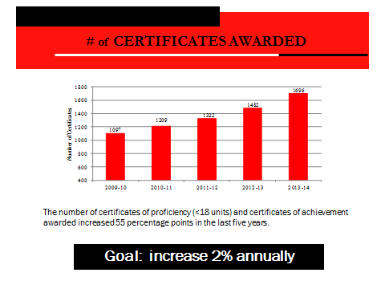

Annotation:
- The baseline is the median of the last five years: 1322.
- 2013-14 data has been added.
- The large increase is due to the fact that certificates are automatically received at this time.
- The Annual Report certificate reporting does not include IGETC and CSU Certification.
- If the increase is 2%, this is 35 certificates.

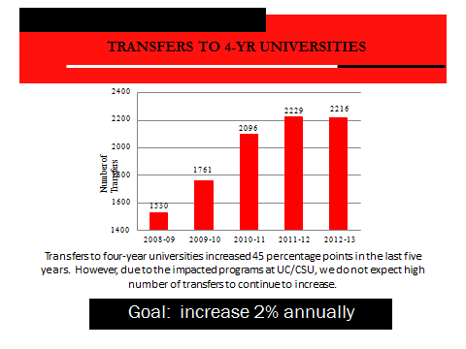

Annotation:
- The baseline is the median of the last five years: 2096.
- 2013-14 data has been added.
- The 5-year mean is 2017; the 4-year mean is 2154 (considering 2009-10 an outlier).
- There has been a drop in certificate completion in 2013-14. The reason must be investigated. It is the recommendation of the Institutional Researcher and the IE&A Coordinator that the annual increase be 2%= 42 transfers (formerly 4%).
- We have yet to see if CSU will honor ADTs
Respectfully submitted,
Omar Torres, Vice President, Academic Affairs
Bonita Nahoum Jaros, Ph.D
IE&A Coordinator/ALO

11/18/14

