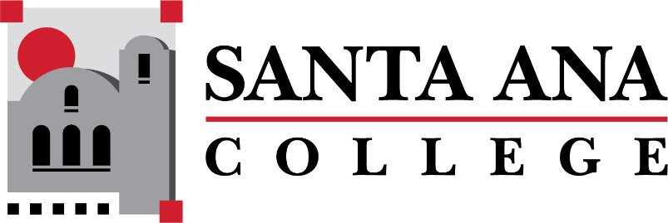

[Dual Enrollment Workgroup](https://www.sac.edu/AcademicAffairs/Dualenrollment/Pages/Dual_Enrollment_Workgroup.aspx) Agenda

Tuesday, December 15, 2022 2:00-3:00pm., Hybrid

S-215 & Zoom

1. Information sharing with high school partners – Matthew Valerius
2. Faculty onboarding and information sharing – Matthew Valerius
3. Course request process & SAC course deadlines (need for annual calendar) – Matthew Valerius
4. Limiting changes to dual enrollment course rosters – Matthew Valerius
5. Bookstore Costs Discussion – Basti Lopez
   1. Spring 2023 Updates

**Upcoming Meetings:**

**Save the Dates: DuE Retreats**

* January 25, 2023 | 9:00am-12:00pm | JSC 219
* May 12, 2023 | 9:00am-12:00pm | JSC 219