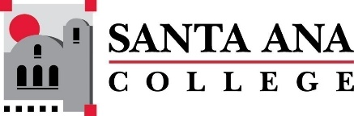 |  | SAC Program Review Committee Minutes  March 11, 2024  1:00 p.m. to 2:30 p.m.  Zoom: https://rsccd-edu.zoom.us/j/87584225311

1. Welcome

2. Capstone Review roundtable discussion with ESL (SCE) and English (SAC)

- Professor Jarek Janio from ESL (SCE) and Professor Matthew Beyersdorf from English (SAC) participated in a round table discussion about their respective departments.

3. Capstone Review roundtable discussion with Nursing (SAC) and the Speech-Language Pathology Assistant Program (SAC)

- Professor Lisa Carriger and Professor Elenor Papa from Nursing (SAC) and Professor Monica Zarske from the Speech-Language Pathology Assistant Program (SAC) participated in a round table discussion about their respective departments.

