SANTA ANA COLLEGE MISSION STATEMENT
Santa Ana College inspires, transforms, and empowers a diverse community of learners.

Academic Senate
Business Meeting Agenda

Name (Original Name) | User Email | Name (Original Name) | User Email
Heather Arazi | arazi_heather@sac.edu | Phillip Marquez | marquez_phillip@sac.edu
Andrew Barrios | barrios_andrew@sac.edu | Dawn McKenna-Sallade | mckenna_dawn@sac.edu
Steve Bautista | bautista_steve@sac.edu | Alejandro Moreno | moreno_alejandro@sac.edu
Jennie Beltrán (she/her/ella) | beltran_jennie@sac.edu | William Nguyen | nguyen_william@sac.edu
Maria Aguilar Beltran (She/Her) | beltran_maria@sac.edu | Suanne Oh | oh_suanne@sac.edu
Matthew Beyersdorf | beyersdorf_matthew@sac.edu | Fernando Ortiz | ortiz_fernando@sac.edu
Annette Bui | bui_annette@sac.edu | Rebecca Vasquez Ortiz ella/she/her | ortiz_rebecca@sac.edu
Ann Cass | cass_ann@sac.edu | Leo Pastrana | pastrana_leo@sac.edu
Amberly Chamberlain | chamberlain_amberly@sac.edu | Kathy Patterson | patterson_kathy@sac.edu
C.J. Hartsock | cjhsigns@aol.com | Luis Pedroza | pedroza_luis@sac.edu
Stephanie Clark | clark_stephanie@sac.edu | Cathryn Pierce | pierce_cathryn@sac.edu
Jodi Coffman | coffman_jodi@sac.edu | Brandon Rocke | rocke_brandon@sac.edu
Molly Colunga | colunga_molly@sac.edu | Juan Rodriguez | rodrigja2@laccd.edu
Claire Coyne | coyne_claire@sac.edu | David Roper | roper_david@sac.edu
Reyna Cummings | cummings_reyna@sac.edu | Reza Mirbeik | sabzevary_mohammadreza@sac.edu
Zachary Diamond | diamond_zachary@sac.edu | Randy Scott | scott_randy@sccollege.edu
Maria Estrada | estrada_maria@sac.edu | Gabriel Shweiri | shweiri_gabriel@sac.edu
Javier Galvan | galvan_javier@sac.edu | Sean Smith | smith_seans@sac.edu
Martha Guerrero-Phlaum | guerrero_martha@sac.edu | Brian Sos | sos_brian@sac.edu
Conor Higgins | higgins_conor@sac.edu | ASL Interpreter: Stephanie Webb | stephanie@yourvolution.com
Susan Hoang | hoang_susan@sac.edu | Michael Taylor | taylor_michael2@sac.edu
Jim Isbell | isbell_james@sac.edu | Dr. Merari Weber (she/her/ella) | weber_merari@sac.edu
Jarek Janio | janio_jarek@sac.edu | Monica Zarske | zarske_monica@sac.edu
Naveen Kanal | kanal_naveen@sac.edu | Bruce Swanlund
Jaki King | king_jaki@sac.edu | Edith Gil
Ali Kowsari | kowsari_ali@sac.edu | Fred Ramsey
Cherylee Kushida | kushida_cherylee@sac.edu | Jeff Lamb
Jeff Lamb | lamb_jeffrey@sac.edu | Jorge Lopez
Kelvin Leeds (He/Him/His) | leeds_kelvin@sac.edu | Karissa Gallego Lovero
Jose Lopez Mercedes | lopezmercedes_jose@sac.edu | Karissa Gallego Lovero (Prof Lovero’s Camera)
Flo Luppani | luppani_flo@sac.edu | Molly Axtell
Roy Shahbazian |  | Naveen Kanal (Naveen)
William Nguyen
Date: Tuesday, May 11, 2021
Time: 1:30-3:30pm
Location: Zoom Webinar Location
____

Meeting Location: https://cccconfer.zoom.us/j/96274327789

Agenda:
- Call to Order – Roy Shahbazian
- Approval of Additions or Corrections to Agenda
- Approval of/or Corrections to Minutes
  - Susan & Ali, 4/23 minutes & 3/23 minutes
  - Approved without objection
- Public Comments
  - Reza Mirbeck has a public comment related to curriculum approval. Noncredit is an extension of the credit side and is basically equal and is represented in Senate. There have been a series of events in Curriculum in which. They are being treated as perhaps a stepchild rather than equal, and would like to see what is equitable. Ask to double or triple check with credit, and they feel it is not reciprocated where credit doesn’t check with noncredit. Make Senate aware and pay attention as well when. One active voting member in CIC, funnel students into credit side. Making changes and improvements.
  - Susan Hoang, public comment on fact that we are reaching end of semester and haven’t been consistent messaging around what we are doing in the fall and is concerned about how we are planning.
  - Reyna Cummings, public comment, concern about online caps, different courses have various caps. Her courses started at 30, then 35 and now it is at 40. A lot of indicidualized work and writing, and her concern is that after things normalize she’s worried there won’t be a discussion. In the past, 20 would make a section. Size of the classroom impacts the quality of education and she is concerned. It was recommended that she bring it up in Senate afte raising the issue in the union.
  - Michael Taylor, a great idea to have Ozzie or Alejandro to make a motion to agendize an educational presentation on what noncredit is all about and how we can work together. Setup a working group to understand noncredit and explore benefits rather than see them as competition.
- Reports
  - SEAP Report – Maria Aguilar Beltran
    - Equity-minded Teaching & Learning Institute. - Maria Aguilar Beltran and Stephanie Clark
    - 4th pillar of GP. Shared presentation.
    - PPT.
    - Limited to 10 people. Kathy Patterson. Work out kinks.
    - Stipends. $1000
    - Karissa Lovero asked it it is open to part-timers.
    - Edith Gil wants to clarify that this is available to faculty.
    - Luis Pedroza, supports this program in moving forward, Susan Hoang has seconded. William mentioned that this is not an action item on the agenda, if not actionable.
    - Yes’s have it motion passes to endorse the Equity-minded Teaching & Learning Institute.
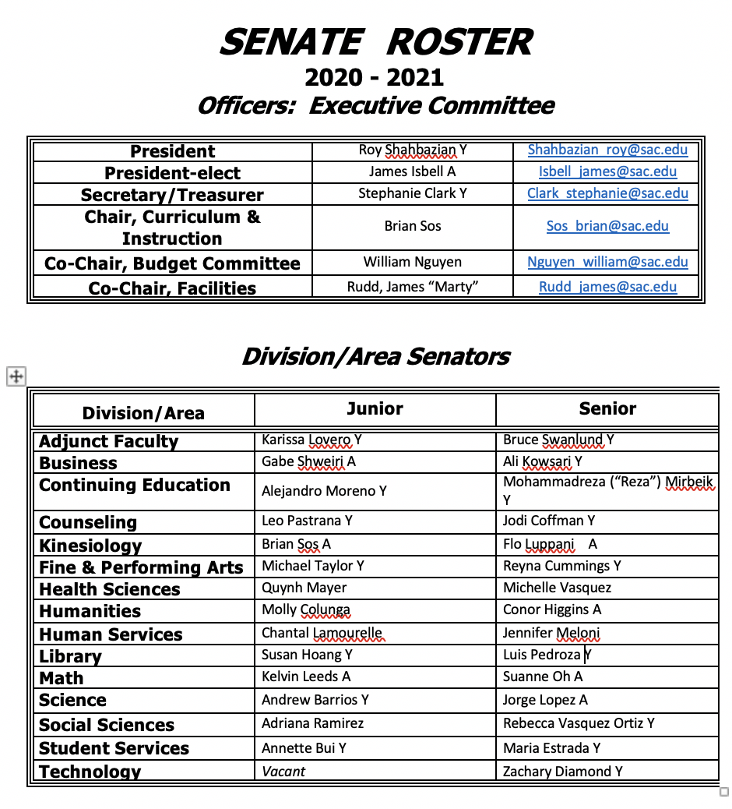
  - ASG Report - Edith Gil
    - 100% smoke free campus.
    - Focusing on the resolution and what they want included in the language. Looking into SCC resolution.
  - SCC Report – Randy Scott
    - Annual plans in eLumen.
    - Working on RAR process, program review, communication arms.
- ​​Proposed Board Policy Changes (20 minutes) Roy Shahbazian
  - Docket was included.
  - 5215 vaccinations for students. Reference BP 5210.
  - Kelvin asked about the walk-ups on campus, will this continue if we are implementing a BP on this topic? Kelvin feels this is important.
  - William would like to keep in mind, are we giving students enough time to get enough time to get vaccinated in fall?
  - Rebecca Ortiz, said there are many ways to access immunization now.
  - Monica is wondering about a timelne for feedback to the board.
  - Jorge is wondering about the end date for this policy, or is this indefinite?
  - Maria Estrada shared that there are several who are not planning to get the vaccine. Will this impact enrollment, we need to consider this.
  - Reyna hopes we can provide resources in which people can make educated decisions and not fear-based.
  - Amberly mentioned that UC or USC couldn’t implement this without FDA approval and that might not happen before fall.
  - Susan Hoang, will testing continue?
  - Rebecca Ortiz thinks we should consider what is going on around us, SAUSD remained online. Some feel this is problematic, if other campuses aren’t doing this we might have students who go to another campus. Reflect what other campuses are doing.
- PT Hiring Recommendations (15 minutes) Work Group Members
  - Shared PT Hiring recommendations.
  - Reoccurring theme of recruitment.
  - Stephanie Clark asked if the group is considering how hiring practices are impacted by our Chair policies and practices?
  - Stephanie asked that as a campus community, if we don’t address our Chair policies, then we won’t see changes in hiring practices. Looking at the data she is not seeing us improving our diversification of faculty, even after launching our intensive EEO training. It’s important to address who is making these decisions related to hiring.
- Forming a Work Group for FT Hiring Prioritization Recommendations (5 minutes) Roy Shahbazian
  - Stephanie Clark, Jim Isbel, and Roy Shahbazian will serve on this group. Roy will reach out to more people.
- Academic Senate Bylaws and Presidency (20 minutes) - Roy Shahbazian, Jim Isbell and Bylaws Work Group Members​
  - Need a couple more meetings for that workgroup.
  - Had one meeting, meeting tomorrow as well.
  - Will return with more recommendations.
  - Jim Isbell said there are some concerns about a conflict-of-interest. He argues that there are examples of this practice across the state (serving on Senate & FARSCCD).
  - Senate President said this job is difficult to do without faculty support.
  - Stephanie Clark shared that she received several questions from members of the body, so she wanted to share those with Jim.
    - Q:Can one person do two roles with such demanding responsibilities?
    - A: Jim shared that there was a Prsident of FARSCCD & Senate.
    - Q: The union represents faculty across the district. What happens when there is a conflict between thse two bodies’ positions. There was an issue last year where this occurred.
    - A: Jim said he could recuse himself if it seems necessary. Jim said he sees this is as a positive rather than a negative.
    - Q: How does having one person in these two role promote diversity and inclusion? Would we be ok with the AS President representing a Division Senator?
    - Jim shared that there is just one vote so that can’t really happen.
  - Kathy Patterson shared that Jim ran unopposed. Recruit leaders.
  - Monica Zarske shared that she has dealt with this issue a lot, she said that we tap a lot, we send announcements, we tap for committees, there are several positions that are not filled and we want and need people on these teams and committees in these positions. As a past-president if others have better ideas about developing a pipline, she’d love to hear this. Very rare that people run opposed. What is holding people back? We need people rotating.
  - Rebecca Ortiz is interested in leadership and was so discouraged by the bias and abusive behaviors in this space. She’d like to acknowledge that there was a group formed to address this behavior within Senate. Rebecca also noted that a presentation on an equity institute was challenged by leadership today, and let’s not ignore that the traditional practices need to be examined so that when people like her are tapped they join.
  - Maria Estrada shared that she’d like to hear from Roy about his time commitment and how would that change if you were a VP for FARSCCD. She is wondering if he has a lot of time available as Senate President?
  - Roy shared that there is a level of burnout and he looks forward to not being Academic Senate President.
  - Susan Hoang wanted to comment on the time it takes and energy required for these positions, when we put too much pressure on one person we do see them suffering from burnout. We are looking in the bylaws about whether you might not serve on other leadership positions
  - William Nguyen shared that he keeps hearing that people aren’t being allowed to enter leadership but when he taps people they decline so we need to admit that this is happening and it’s a good idea to evaluate the bylaws to support getting more people into leadership.
  - Stephanie Clark shared that it is a little confusing, she isn’t sure if we are talking about Jim’s position or the bylaws, so the way it is presented on the agenda is confusing.
  - Stephanie also wanted to acknowledge the points made by William and Rebecca, Stephanie is concerned that there have been troubling incidences on this campus and is concerned that leadership does not acknowledge the events that have actually occurred. Until those things are acknowledge, we will be talking in circles, because we’re pretending that the problems don’t exist that need to be addressed, so she encourages everyon to have brave conversations about why people aren’t wanting to get involved. She feels others don’t get involved in leadership either because the government is not reflective of their values or they are concerned about how voices are uplifted or silenced and she asked that we be honest about how we can change things for the positive and the bylaws conversation is a space where we can discuss very real change and reflect some of the values that our faculty cherish.
  - Roy asked about next steps on this topic and Stephanie shared that she isn’t sure if this is a discussion about bylaws or our upcoming president, she feels these topics should be separate.
  - Jim agrees and feels this is too late to discuss, he’s happy to talk directly with people about this. Jim shared that 3:30 is his limit.
  - Roy thanked Jim.
- Rep​orts:
  - President – Roy Shahbazian
    - Work Group report – meeting again this week.
    - Fall Schedule, there might be difference of opinion between local administration and district.
    - Potential July 17, AS meeting​.
  - Secretary/Treasurer – Stephanie Clark
  - Guided Pathways – Stephanie Clark
  - Curriculum – Brian Sos
  - Planning & Budget – William Nguyen
    - Expenses that were not shared with P&B committee.
    - William feels that decisions are made and then quite a time later P&D is informed. William shared how these practices need to align with accreditation standard three.
    - Permanent positions are critical for P&D to know.
    - He wanted Senate to know there are some issues here and he welcomes questions or comments to bring back to the committee.
    - Susan Hoang is wondering what senate can do for William? She isn’t sure if there is a motion needed.
    - William confirmed this is just a report.
  - Facilities – James (Marty) Rudd
  - Faculty Professional Development – Amberly Chamberlain
- Funds left over to spend. AS Leadership Institute is available.
- Surveys need to be take for PD. Trying to figure out flex and convocation, so they need these surveys completed to remain informed of what faculty want/need.
- Dual Enrollment pedagogy support group has been formed.
  - Student Success & Equity – Maria Aguilar Beltran
  - SACTAC – Susan Hoang
  - Outcomes/Assessment – Jarek Janio
  - Upd​ated ILOs
  - Accreditation– Monica Zarske
- .Announcements
- Adjournment

