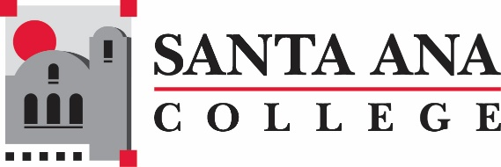
Civic Engagement Meeting
Wednesday, October 7, 2020 10:30a.m., Zoom Meeting

Present: Stephanie Clark, Amanda Farah, Susan Hoang, Young Kim, Teresa Mercado-Cota, Michell Sandoval

Not able to attend: Amberly Chamberlain, Janet Cruz-Teposle , Ivette Fisher, Ashely Gonzales, Megan Lange, Jonathan Medina, Raquel Serratos, Roy Shahbazian
Agenda Items | Notes/ Required Action
- Welcome  - Introductions | Introduction of all participants at the meeting.
- Partnerships  - Meetings: SAC and Others  - Invites  - Sub-committee or committee  - Other | Teresa brought AB963 legislation- topic for next Civic Engagement meeting. Main focus is the U.S. Census and voter registration right now for the month of October.  Amanda to send Ballot Bowl notes to all of the team. Ballot Bowl is a friendly competition to motivate students and educate about voting and the purpose of voting. Teresa asking that everyone send and share this in different meeting, Academic Senate and other groups. Young through social media.  All In Challenge is to help Civic Engagement to be a meaningful and permanent part of the SAC Campus Culture. SAC submitted a DRAFT report in late May and we were informed that more substance is needed. The next report is due in November.  The Census has been extended until Oct. 31 as of now.  Susan Hoang: Discussed process on election guide website that is provided for the students, under the (Nealley Library). Website will be through SAC site. Providing students information on registering to vote, voting, voting protocols and propositions. Young agreed to providing this information and link to Staff and students through social media. Public Affairs will share through SAC Public Affairs email. Michelle Sandoval will publish through CEC.  Michelle spoke about CEC students creating videos of why voting matter. This will be advertised and posted all throughout next week before virtual webinar. Asking to make the videos in Spanish, Vietnamese and Chinese.  Discussion on to Professional Development team the option to gain flex hours to faculty. This could be brought up with the by Teresa to the Advisory Committee.
- Calendar  - Fall  - Event/Activities  - Institution/Conferences  - Webpage  - Other | Michelle discussed participation of CEC campus, the design of a website, and getting more students engaged with civic engagement and voting. Discussed through SAC and CEC to promote ideas to give faculty information to provide to students.  Why Voting Matters/ Voter registrations – October 14, 2020 at 12:00pm  October 15, 2020 at 4:00pm, October 16, 2020 at 4:00pm (Spanish)  Virtual webinar will include a pamphlet including, voter registration date guideline, easy access links for registering and voting information.  Santa Ana College will be used as a voting site from Oct. 29- Nov. 3 (Young Kim has been and will continue promoting this on social media)
- Civic Engagement Communication Plan  - Targeting faculty | Stephanie Clark, is helping with promoting to faculty and asking that they engaging students in the classroom with Civic Engagement.
- Next Meeting  - Dates and Details | TBD

H: SAC Public Affairs.AF.Civic Engagement Meeting.10.07.2020 Notes

