Santa Ana College
Protocol for Instructional Spaces
Fall 2020

Per the RSCCD Return to Work Action Plan (v6 7-13-2020), the RSCCD Return to Work – Instructional Spaces Guidelines, RSCCD COVID Communication Protocol the information in this document will provide details regarding the protocols to follow for Santa Ana College Instructional Spaces.

Prior to the beginning of the semester it is imperative that all faculty and staff become familiar with the following documentation:
- RSCCD Return to Work Action Plan
- RSCCD Return to Work – Instructional Spaces Guidelines
- RSCCD COVID Communication Protocol
- SAC Protocols for Instructional Spaces
  - Campus Access Procedures– Faculty & Students
  - Academic Issues – Syllabus Statement, Daily Attendance, Grading, P/NP, EW
  - Response to COVID Symptoms/Tests
  - Classroom Management – Sanitation

Protocols for Academic Issues related to COVID-19

- Syllabus Statement (to be confirmed by AS) :
Please include the Standard Syllabus Statement during COVID-19 - FALL 2020 which has been reviewed by the Academic Senate in all syllabi for classes meeting on campus.
The nature of the current pandemic requires awareness of everyone who is physically present in a college classroom or laboratory. In order to achieve the learning objectives of this course, it is necessary to conduct a number of laboratory exercises in-person while observing full safety protocols. Students will attend these required laboratory sessions in small groups as assigned by the instructor and must observe all safety and health precautions at all times while present.
Prior to Arrival
Each student must conduct self-symptom monitoring. You must be free of ANY symptoms potentially related to COVID-19. At this time, these symptoms include:
- Cough
- Shortness of breath or difficulty breathing
- Fever – Greater than 100 degrees (Temperature checks will be conducted prior to entering the classroom/lab)
- Chills
- Muscle pain
- Sore throat
- Loss of taste or smell

If you have any symptoms:
- You must call your primary care provider for assessment of symptoms and/or COVID-19 testing.
(Is a Dr. Note required to confirm/return? - TBD by DO?
- You should self-isolate until cleared by your doctor to return to class.
- Inform your instructor and do NOT come to your class (laboratory session).
During Classroom/Laboratory Session
The following hygiene protocols must be observed at all times:
- Maintain a minimum 6 ft distance from all others.
- Wear a face mask and other personal protective equipment as required by your instructor.
- Regularly wash hands for 20 seconds with warm water and soap.
- Cover coughs and sneezes.
- Avoid touching your eyes, mouth and nose.
Your instructor will provide you with ‘Sanitizing Procedures’ for each lab session and all students will be required to complete their part.
Important Note:
All students must understand their instructor may deny them access to the class or laboratory to preserve the health and safety of other students and staff. If you are asked to go home due to symptoms, or for not following other safety rules, please leave the campus immediately. Any questions or concerns can be addressed in follow-up communication with your instructor. A non-compliant student will be escorted off campus by Campus Safety Officers.
During this pandemic, students may be denied entrance to the campus and/or laboratory; or students may miss class due to quarantine. Your instructor will provide information on alternative assignments that can be completed out of the classroom to make up the assignments.
There is always the possibility that the class will be required to move away from any in-person meetings and to become fully remote. Please be aware of this possibility and expect changes to lab assignments if we are required to move to remote lab instruction.
Admissions and Records has approved a COVID-19 related excused withdrawal (EW), as well as extending the deadline for Pass/No Pass option. These options are available until December 18, 2020. More information can be found at Admissions and Records: https://sac.edu/StudentServices/AdmissionsRecords/Pages/default.aspx

- Waiting Areas –

Faculty will work with their Dean to develop plan for student waiting areas that are appropriate to the facilities where classes/labs will be held.

The faculty will include this information in the class plan/syllabus and/or provide a video to guide students. This should include:
Waiting areas prior to class
Queue up for class entrance and health screening

After Class/Laboratory Session
After laboratory session students are required to leave campus. If students are to be picked up from campus (Uber. Lift, Bus, family member, friend, etc) students are to wait at the designated drop-off/pickup area in front of the planetarium. Masks and social distancing are to be practiced at all times. Facilities will identify waiting areas and communicate this to faculty/students.

- Attendance (To be confirmed by AS)
In order to help ensure that attendance information is readily available if needed and to aid in the future possibility of automating reporting tasks; faculty teaching in-person classes are encouraged to take daily attendance using Canvas.
By using the Canvas attendance feature student information will be readily available.

Student Issues:
- If a student becomes ill, tests positive, and/or must quarantine due to COVID-19:
  - Assignments and exams must be made available remotely, preferably on Canvas. Students should have the ability to also submit assignments/take exams remotely during their absence.
  - Lecture material (e.g., PowerPoint slides, handouts, recordings) should be made available to students who need to miss class.
  - If students are unable to complete assignments due to personal illness, positive test, or a need to care for an ill family member, flexibility should be used in assigning final grades (e.g., using an average on three exams to assign a grade for a missed exam).
  - There should be no negative consequence for absences.
  - A doctor’s note is NOT required to justify an absence or missed assignment due to COVID-19.
Faculty Issues:
- If a faculty member becomes ill, tests positive, and/or must quarantine due to COVID-19:
  - Prior to the beginning of the semester:
    - Faculty should prepare the course to easily transition to Remote/Online Instruction, if needed.
    - When possible, division Dean, in consultation with faculty, should identify an alternate instructor for the course.
  - Once it is determined that a faculty member must abandon his or her course, either temporarily or for the duration of the semester, division Dean and faculty will determine if the course will remain face-to-face with alternate instructor, revert to Remote/Online instruction or another hybrid modality.

- Grading Policies:
- Pass/No Pass Deadline is December XX, 2020
Due to the impacts of COVID-19 Santa Ana College has implemented the following temporary policies:
- Allow students to file for P/NP until XXXXXX, 2020 for the Fall 2020 term.
- Units taken as P/NP in Spring and Summer 2020 are not limited by the per-semester maximum nor count toward the per-degree maximum included in the Catalog and AR4232.
- Allow students to take major courses as P/NP in Spring and Summer 2020. Before approving P/NP petitions, counselors will advise students about varying policies regarding P/NP from the UC and CSU, scholarships, graduate schools and for international students.
- For Associate Degrees, units earned at another regionally accredited college or university on a Pass/No Pass basis during Winter, Spring and Summer 2020 will be counted toward the Santa Ana College degree requirements and will not count toward the limit in the Catalog and AR4232.
- Students are required to meet with a counselor or attend a counseling workshop prior to submitting a petition for P/NP.
- ​Questions contact Counseling: www.sac.edu/ Counseling
- Additional details and required forms can be found at: https://www.sac.edu/StudentServices/AdmissionsRecords/Pages/Pass-No-Pass-Formerly-Credit-No-Credit-.aspx

- Excused Withdrawal – Deadline is December XX, 2020
For those who need to withdraw from a class, the California Community Colleges Chancellor's Office (CCCCO) is allowing students to withdraw without penalty because of the current national COVID-19 crisis.
- If a student longer wishes to continue enrollment with current course(s), they may request an Excused Withdrawal (EW) with a refund of enrollment fees ($46/unit).
- Those who received the California College Promise Grant Waiver are not eligible for a refund.
- The EW will not count against academic progress, probation status or towards the permitted number of withdrawals/attempts.
- The EW, however, may affect other benefits such as Financial Aid, Veterans, Sponsorship​, Athletics​, etc. If the student is receiving these types of benefits, it is recommended that they contact the appropriate program to determine if there are ramifications to requesting an EW.
- Additional details and required forms can be found at: https://www.sac.edu/StudentServices/AdmissionsRecords/Pages/Covid19_Excused_Withdrawal.aspx

Protocol for Campus Access
It is the responsibility of each individual to perform a health self-assessment each morning before coming to campus. This includes taking one’s temperature. If the temperature is 100 degrees or above, the individual must not come to campus. If an individual is not feeling well, they should not come to campus. Staff or students who are sick or are showing signs of COVID-19 should stay home and not come to campus. You must be free of ANY symptoms potentially related to COVID-19 or have had evaluation and clearance by a doctor to be eligible to report to work. At this time, these symptoms include one or more of the following:
- Cough
- Shortness of breath or difficulty breathing
- Fever – Greater than 100 degrees
- Chills
- Muscle pain
- Sore throat
- Loss of taste or smell

Temperature checks will be performed on all faculty and staff prior to entering the instructional space to determine whether or not their temperature is over or under 100F
While on campus, facemasks must be worn in public places or when another person is nearby, and social distancing must be practiced at all times to the extent possible.
Disposable face covering will be provided to any student and staff member who needs one. Cloth face coverings will be provided to all employees. Reusable face shields will be provided to instructors who want one, and identified staff members. A non-contact thermometer will be available in all classroom/lab spaces in which face-to-face instruction is taking place.

- Administrators/Staff –
Re-Occurring On-Campus Work Schedule
- Request re-occurring campus access (days, time, location, purpose) from supervisor.
- Submit request in Campus Access Spreadsheet (need a new tab for Re-Occurring)
- Dean of the Day (?) – do we need an administrator on site to deal with issues (AA Team)?
- In the event a re-occurring activity is not met (called out sick) – notify supervisor and Facilities Coordinator

Non-Regular Campus Visits
- Administrators/Staff will request campus access (date, time, location, purpose) from supervisor by Thursday of the week prior.
- The request will be submitted on the Campus Access Spreadsheet.
- Approval/Denial will be confirmed by the VP of Academic Affairs (Jeff Lamb) on Friday of the week prior.
- The approved Campus Access Spreadsheet will be submitted to the
  - President (Marilyn Flores)
  - VP of Administrative Services (Bart Hoffman)
  - Director of Facilities (Mario Gaspar)
  - Facilities Coordinator (Maria Taylor)
  - Safety Office (Scott Baker)
- Emergency Approval (e.g. technology issue)
  - Contact Supervisor who will request approval from appropriate VP
  - Add request to list
  - VP Office notifies Facilitates Coordinator with update.
- Faculty –
Office/Non-Teaching Classroom Visits –
- Faculty will request campus access (date, time, location, purpose) from supervisor by Thursday of the week prior.
- The request will be submitted on the Campus Access Spreadsheet
- Approval/Denial will be confirmed by the VP of Academic Affairs (Jeff Lamb) on Friday of the week prior.
- The approved Campus Access Spreadsheet will be submitted to the:
  - President (Marilyn Flores)
  - VP of Administrative Services (Bart Hoffman)
  - Director of Facilities (Mario Gaspar)
  - Facilities Coordinator (Maria Taylor)
  - Safety Office (Scott Baker)

- Students –
Attending F2F Classes:
- Faculty will confirm the dates, times and locations for each class meeting throughout the semester to appropriate Dean.
- This information will be included in the Fall 2020 Campus Presence Detail spreadsheet.
- This document will be provided to:
  - Facilities Coordinator (Maria Taylor)
- Who will distribute it to:
  - President (Marilyn Flores)
  - VP of Administrative Services (Bart Hoffman)
  - VP of Student Services (Vaniethia Hubbard)
  - Director of Facilities (Mario Gaspar)
  - Safety Office (Scott Baker)
- Student Arrival on Campus
- Guidelines: COVID-19 Temperature Screening
  - Touchless, non-contact infrared thermometers (NCIT) must be used
  - Follow strict social distancing requirements per device manufacturing guidelines
  - Masks covering mouth and nose must be worn by both instructor and student
  - Ensure test area of the forehead is clean, dry, and free from hair during measurement
  - Temperatures screening should be done before entering class
  - Ensure adequate cleaning per product instructions between uses
  - Normal Temp threshold - Only normal temperatures (less than 100.4°F [38 °C]) are safe to enter class
- The CDC considers fever as temperature measuring of at least 100.4°F [38 °C]
  - If temperatures are equal or in excess to 100.4°F [38 °C], follow SAC protocol for student with symptoms.
  - Note, fevers may be suppressed with medications and other methods. Also must observe for presence of flushed face, glassy eyes, or chills. These are other assessments of detecting possible fever despite normal temperature result.
  - If temp is 100.4°F or above and believed to be temporary, direct student to social distanced area to wait 5 mins for temp recheck.
  - High temperatures may be temporarily caused by:
    - Hot weather
    - Intense physical activity
    - Type of clothing
    - Menopause
  - If second temp results above 100.4°F, student must leave campus immediately and will be given makeup work and

  - Students must complete the RSCCD Acknowledgement and submit it to faculty on or before first class meeting
  - The RSCCD Acknowledgement must be completed by every student (Don Maus).
  - The document may be stored in Canvas for each class.
  - Hard copies of the RSCCD Acknowledgement will be provided to the faculty for the first day of class should they be needed for students adding the class, etc.
  - Faculty will maintain the hard copies for each class.
  - Students will be encouraged to remain home if they are sick or have symptoms.
  - If students arrive on campus and show symptoms please refer to the steps below.
  - Should there be an COVID positive case please refer to the steps below.

Access to Campus for Computer Center, Learning Center, etc.:
- Students will be required to make an appointment to work in the desired center.
- Each center will determine the best method of accepting and monitoring appointments. (e.g. software, hard copy, spreadsheet, Cranium Cafe)
- Students will provide a signed RSCCD Waiver
- All appointments will include the student name, student ID, date, time and location.
- Appointment lists will be uploaded at the end of each week to the H: Drive/Teams sheet
- The Folder/Team will accessible by Deans, Division Office Staff, President, VPs & Safety

Protocol if Student Shows Symptoms
(Potentially Sick Students)
Student with Symptoms:
- Students who have symptoms when they arrive for class, such as a coughing, sneezing, or temperature over 100 F as determined by a non-contact thermometer, should immediately be separated from other students/faculty and sent home.
- Students who develop symptoms outside of campus should notify their instructor immediately and stay home.

Student without Symptoms (possibly exposed):
Students may have been exposed if they are in “close contact” with someone who is infected, which is defined as being within 6 feet of a person with COVID-19 for a prolonged period of time (15+ minutes)
- Potentially exposed students who do not have symptoms, may be an asymptomatic carrier, and therefore should remain at home and practice social distancing for 3 days

Close Contact Considerations—
- Classmates who have come into close contact with a symptomatic student should be advised to self-monitor for symptoms of COVID-19, and consider self quarantining for 10 days.
- The instructor should advise the Dean that a student reported feeling unwell and left the classroom or didn’t come to school.
- Students should be instructed to report any symptoms of COVID-19 to their instructor.

Cleaning/Disinfecting:
- All surfaces, tools and equipment (touched by the symptomatic student) in the classroom should be cleaned and disinfected in a manner consistent with CDC guidelines.

***Definition of Close Contact***
Close contact is defined as: being within approximately 6 feet of a COVID-19 case or within a closed space for a prolonged period of time (15 minutes), or
Having direct contact with body fluids of a COVID-19 case (e.g., being coughed on).
To further understand risk, it is important to consider the specific types of close contact. Examples include: Sharing a desk, lab supplies, computer keyboards, etc.; sharing tools, interacting with equipment; Sharing lab coats, safety glasses, or gloves; Sharing food, drink, or service ware, etc.
*Contact needs to have occurred within the symptomatic period or the 24 hours before onset of symptoms.

Tests for COVID During a Face-to-Face Class

Guidelines provided by the following on how to return to campus and how to communicate with students/staff/faculty are the starting point for this protocol.
- California Department of Public Health
- RSCCD COVID-19 Communication Protocol, based on CDC Guidelines
- CCCOC – Report of the Safe Campus Reopening Group
The key is that we have to be nimble and flexible. We recommend the following actions:
DURING THE SEMESTER (when a COVID case is reported)
- The class roster will be pulled for the class.
- The RSCCD Communication Procedures will be followed to notify students
- The entire class must quarantine for 14 days.
- Vacate room for 72 hours for thorough sanitation (may include the entire building).
- Class will be moved to an alternative space?
- Remote Instruction. Instructors should have at least 2 weeks’ worth of materials ready to implement remotely to prevent loss of instructional time.
- Provide flexibility with class deadlines regarding tests, assignments, reports, etc.
- In case there is a second case reported (and need to isolate for another 2 weeks), apply another round of remote-instruction materials.

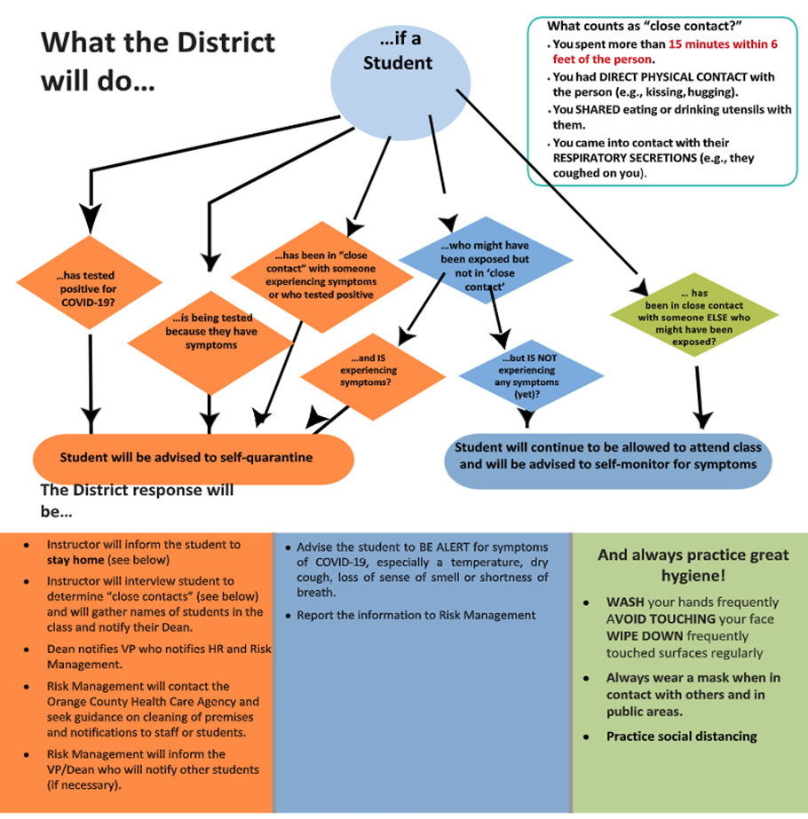

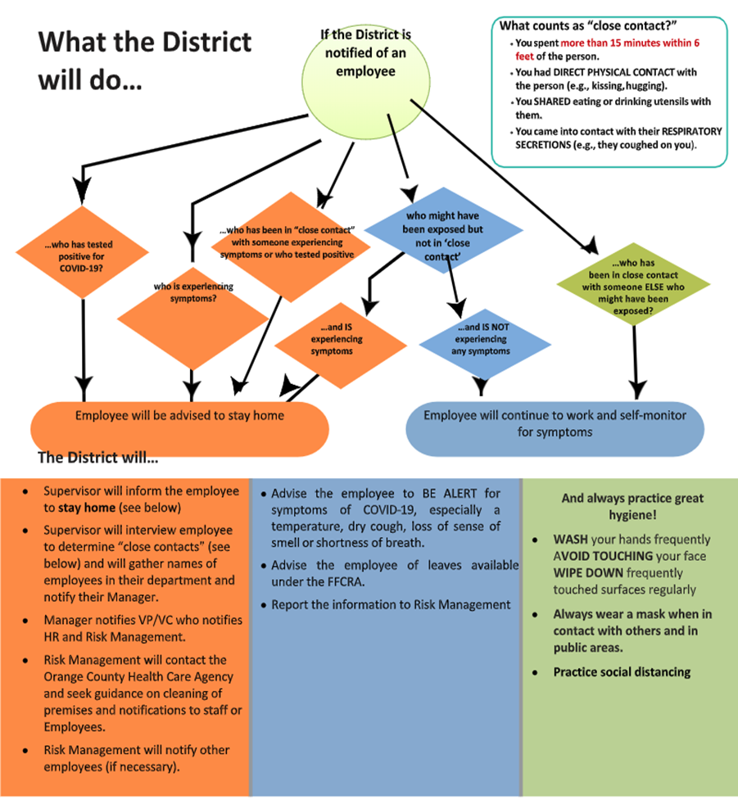

Protocol for Sanitizing Classrooms

Face covering (mask or shield) MUST be worn at all times
Observe social/physical distancing (>6ft) guidelines.
Start of the class/lab:
STUDENTS:
  - Thoroughly (>20 seconds) wash your hands with soap and water or use hand sanitizer, as instructed
  - Wipe down your benchtop surface and the adjacent work areas with disinfectant
  - Wipe down the sitting surface of your stool or chair with disinfectant
  - Wipe drawer handle(s) of your work area with disinfectant
  - Dispose used paper towels in waste bin

INSTRUCTORS:
- Wipe down instructor area, desk/table and chair, with disinfectant spray and paper towels

During the class/lab:
STUDENTS AND INSTRUCTORS:
- Wear personal protective equipment as instructed (gloves may be required)
- Keep interactions with fellow students to a minimum
- Wipe down shared instruments (e.g.: microscopes, balances) with alcohol wipes before use and between users if applicable
End of the class/lab:
STUDENTS:
- Wipe down your benchtop surface and the adjacent work areas with disinfectant
- Wipe down the sitting surface of your stool or chair with disinfectant
- Wipe drawer handle(s) of your work area with disinfectant
- Throw paper towels in waste bin
- Thoroughly (>20 seconds) wash your hands with soap and water

INSTRUCTORS:
- Wipe down instructor area, desk/table and chair, with disinfectant spray and paper towels

Between classes/labs:
- Stockroom staff will check sanitizing supplies for all lab benches and tables and refill as necessary
- Stockroom staff will disinfect the service window counter if applicable
- Stockroom staff will disinfect any door handles between lab and stockroom if necessary
At End of Each Day:
All lab and class spaces used that day will be cleaned per CDC protocols by Maintenance and Operations. It will be clearly evident that the space has been thoroughly cleaned, properly sanitized and disinfected including but not limited to trash removal, surface cleaning, etc.

