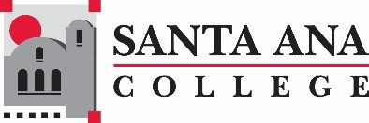

Remote Instructor Certification
Santa Ana College requires instructors to complete the Remote Instruction Certificate for emergency remote instruction teaching.

Remote Instruction Certificate
- Canvas Silver Certificate
  - Assurance of Title V, Accessibility, FERPA, 10 flex hours
- Canvas Silver Badge
  - Self-paced on Canvas training, 10 flex hours
- Accessibility Training
  - Self-paced accessibility, 3 flex hours
- Virtual Conferencing Training
  - Self-paced conferencing training, 1 flex hour
Training will assure faculty have training for required: Title V, instructor contact and student-student contact, Section 504 of the Rehabilitation Act of 1973 and the Americans with Disabilities Act of 1990 (ADA), Family Educational Rights and Privacy Act (FERPA) (20 U.S.C. § 1232g; 34 CFR Part 99) protecting the privacy of student education records

Note:
Faculty assigned an online class will be required to have the current Online Teaching Certificate (No change to present policy).

