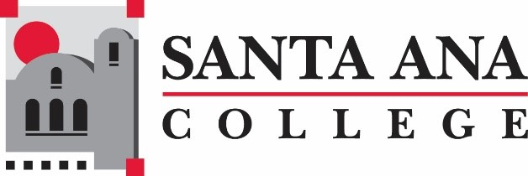
Curriculum and Instruction Council Report
5/24/2022
AB 928 Update
The Special Committee on AB 928 met three times to discuss the singular general education (GE) transfer pathway. After considering several options and patterns, the group came to consensus on a pattern that it believes satisfies the legislation's requirements for both a clear and transparent singular pathway, and maintaining at 34 the total units required to complete the lntersegmental General Education Transfer Curriculum (IGETC). The recommendation is best understood by the attached chart. Any questions reach out to Claire (coyne_claire@sac.edu) and Paula Canzona, Articulation Officer (canzona_paula@sac.edu)

For Fall 2022:
Class Size Maximum (class caps) Workgroup: Anyone interested in developing a policy and processes for class caps, please email me (coyne_claire@sac.edu)
Discussion to include Minimum Qualifications on the Course Outline of Record
The ASCCC’s adopted position is that discipline designation should be an element of the COR. The ASCCC paper Qualifications For Faculty Service In The California Community Colleges: Minimum Qualifications, Placement Of Courses Within Disciplines, And Faculty Service Areas (2004) states, “For clarity and as a convenient reference, discipline designations should appear on course outlines of record.” Such an indication in the COR can also be an effective practice to prevent confusion in multi-college districts.

Professional Development February 2 Via Zoom (1:10-3:10pm)
Best Practices for Courses and Programs due for Quadrennial Review ~ Claire Coyne, Stephanie Clark
Quadrennial Reviews (courses and programs) due by October 17

Mission Statement Santa Ana College inspires, transforms, and empowers a diverse community of learners.

