DE Advisory Group Summary
Time: 10:30am to 11:30am, November 16th
https://rsccd-edu.zoom.us/j/86514095220 or join Jaki in her office L 104
Welcome
Present: Jaki King, Maggie Manzano, Marvin Gabut, TJ Naman, Rick Castillo, Michelle Kimmel, Jennie Beltran, Crystal Jenkins, Jason Sim, Heather Arazi
Group discussed class maximums and the beta survey: Collected Articles, Research, and Examples so far
  - Review collected survey responses – see below for the qualitative answers that we reviewed.
    - Summary with charts
    - All the data
- I don't believe there is a one size fits all answer to the ideal class size. There are several issues that should be considered. Among them would be the type of course that is being offered and the learning objectives that are being addressed. Is it a traditional type course or is it a lab environment? Some studies have shown that 30 students is an ideal class size, (Taft, et al., 2019). It is thought that larger courses can present a challenge when the instructor is trying to implement the Community of Inquiry framework (Garrison et al., 2000). Of course a smaller course allows the instructor to interact more with students. Some research also indicates the smaller course size helps to eliminate instructor burn out. Oregon state recently conducted a study that showed 'students' grades were higher in certain online classes that had lower enrollment (30 or less) (OSU Ecampus Research Unit, 2021).
https://ecampus.oregonstate.edu/news/online-class-size-research/
Thomas, R. 2021. Student outcomes in online courses: When does class size matter? https://journals3.oregondigital.org/nwelearn/article/view/5608/7333
- Yes, they should be the same as the online courses, and it is unequitable that math courses have higher enrollments than many other disciplines.
- Online classes should be limited to 30 students. Fave to face is easier to instruct a larger size.
- Online courses require response for each student. The student management is similar to independent studies in that each student requires individualized attention instead of a whole class setting.
- Online or in person alone doesn't impact course enrollment - the course design does. The more students enrolled in a class the less time I will have with them and the more pedestrian I''ll have to make the course. Conversely, the less students I have in a Course the more robust I can make the experience.
- The numbers above are per section (so 1-2 hours communication with students for just one section, though I teach three sections - four if I am not department chair). Also, I counted more student communication for in-person classes because I included the hours of class time.
At SAC, we have extensive online training to learn how to teach effectively. When we follow that training, we spend MORE time on the course - at least in my discipline. My prep time for online courses is lower now because I have a lot of material to work with. However, any changes to a course (or teaching a new course online) significantly increases that number. Creating my classes online the first semester took more like 3-5 hours PER DAY, not per week. Changing the novel I teach would add hours of prep. Changing assignments adds hours of prep.
Providing clear and effective feedback online takes many hours per week of work, and it is difficult to keep up with. Taking a whole weekend off of grading almost guarantees getting behind. During the semester, most English professors work at least six days a week, if not seven.
- The accounting subject and the two classes that I generally teach, which are the two introductory classes to accounting for all business administration students; tends to be challenging for most students and students need instructors attention, guidance, and lots of feedback. My classes are at 40 maximum capacity but I generally add up to 5 more. At 45 students per class, it is difficult and extremely time consuming to provide the students with the attention that they need. My week is usually filled with student appointments via ZOOM.
- Course maximums should be the same for online and face to face courses. Specifically for ASL, online courses can be harder for large classes because we cannot see each student clearly when their Zoom screen becomes smaller than 3 inches. It also becomes harder to provide feedback on assignments because the instructor needs to create a video to provide feedback.
- They should absolutely be capped the same as an in-person class is. There is no difference in the time it takes to provide feedback for students- in person or online- except that writing it out actually takes longer.
- Next semester, I have chosen hybrid courses (asynchronous online courses with in-person exams), so I will need a room that can accommodate all of my students for their in-person exams at the same time to provide consistency.
- Title 5 Section 55202 "The same standards of course quality shall be applied to any portion of a course conducted through distance education as are applied to traditional classroom courses." Seems to provide, in part, a justification as to why the same maximums should apply. The course outline also established the same academic criteria the course no matter of the modality. However, I can see an argument that online classes take more time to administer because they do. For example, in a face-to-face I can coordinate and assess student performance faster. Imagine students bringing in a rough draft of a written assignment. If I walk around looking at every single paper as a first "round" draft it will take me probably an hour in a class of 20. In an Online course that same activity take AT LEAST twice as long (interfacing with technology is slower, ironically). Then there are many in-person strategies that speed up that process that I can't do online (why?, because in class I can speak to all the students simultaneously, get instant feedback from all students at once, and then respond all at once). In an asynchronous online class you can't do that. So it requires more time.
- I think this survey is great because I have heard other faculty state that 40+ in an online class is much more difficult, time consuming, and overwhelming compared to teaching in-person. We have added 50+ in a class since one section had 40 students enroll and the second section only have 10 so it was asked of us in the past to rollover the low number into one class which is way too much. It would be have been better to have 2 sections of 25 students for the same amount of work as a 50+ class but we don't get the pay for the extra time and effort. I think this is an issue since I have heard other faculty on campus express the same view.
- The cap should be the same for online and in person. The time spent is on grading, not the number who view pages or attend a lecture.
- Yes, with writing class, I've requested that I have no more than 25 students since they write between 4-5 drafts and final essays within an 8-week course. If it exceeds 25, it is too much and not enough time to give personalized feedback to their peers. With my other class, I can do more because it is less writing. Since I teach hybrid, space is not an issue. If the course is in person, then the room capacity is critical.
Based on this the group decided on the following:
- We will now send this out to all SAC and SCE faculty for responses.
- We will add a question to the end about whether or not a “class maximum” should be added to the COR.
- We will also discuss with CIC about the possibility of adding this information to the COR, such as this example below:
  - 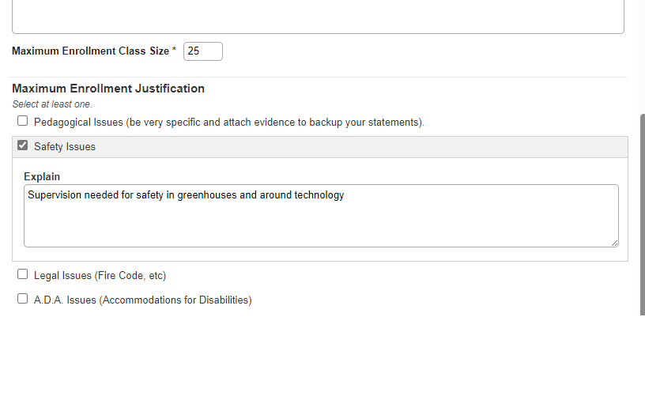
- In the meantime, our collective response based on the beta survey is that online and in-person maximums should be the same and that the cap should be discipline/department specific.

Jaki reminded the group that Proctorio will still be available until the end of this academic year (spring 2024) and it was looking like we are getting another academic year (till Spring 2025) district funded. However, we will need to use this time to find an alternative and get away from Proctorio.
Consider Respondus webinars
Heather Arazi presented on how Mt. SAC is paying more for online class instruction. It was just recently ratified that faculty teaching an online course get a 2% pay increase. This isn’t public knowledge yet but could be something to bring to the Senate and Union next semester.
Intersession and Spring Template updates: Templates with updated links and videos have been sent to district and should be loaded for faculty after thanksgiving.

Jaki sent out Spring 2024 DE meeting invites. We will be meeting the 2nd and 4th Wednesday’s from 10am to 11am.

